Audit of the legislation and the institutional practices of the University of Namur (Belgium) taking into consideration the principles of
the European Charter for Researchers and the Code of Conduct for the Recruitment of Researchers
Gap analysis

Document approved to the Board of Directors of the University of Namur, 26/10/12

The University of Namur has ratified the European Charter for Researchers (Charter) and the Code of Conduct for the Recruitment of Researchers (Code). These two documents seek to promote a human resources strategy that can improve the working conditions and the recruitment of researchers.

This document consists of an audit of the legislation in force and the institutional rules and practices of the University of Namur taking into consideration the principles of the Charter and Code.

The 40 principles of the Charter and the Code were divided into two categories:

- The principles that apply to researchers in their research activities: intellectual property rights, relationship with their supervisor, career development, teaching and research responsibilities, evaluation;

- The principles that apply to researchers in terms of their career management: recruitment and selection, conditions of work and research, recognition, gender and discrimination protection, complaints and appeals process, and participation in university bodies.

Within the framework of the actions to be undertaken, the present document often refers to "AXEL", "Axis for Excellence". This is a major project initiated in 2012 by the General Assembly of the University of Namur. It sets out the strategic lines that will guide the actions of the Board of Directors. The document is structured in four complementary sections: it defines the identity of the university; specifies the cultural evolution of the institution, based on three key dimensions; states the ten major strategic lines of action of the University of Namur and fixes the way in which the General Assembly intends to verify the proper implementation of these strategic lines by the Board of Directors. Several components of AXEL are directly connected with Euraxess Rights.

Part 1: Principles that apply to researchers in their research activities

  - Intellectual property rights: publication, dissemination & use of results

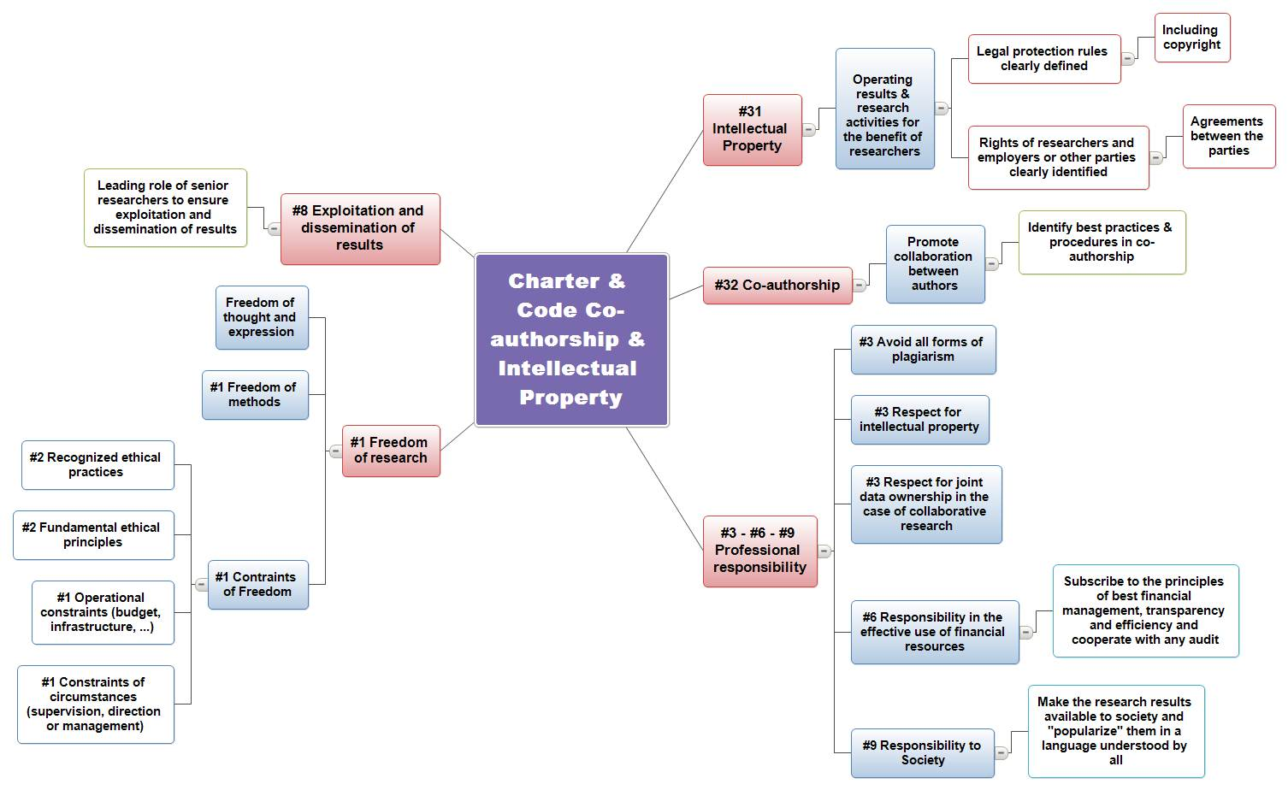
#1. Research freedom (Charter). Researchers should focus their research for the good of mankind and for expanding the frontiers of scientific knowledge, while enjoying the freedom of thought and expression, and the freedom to identify methods by which problems are solved, according to recognised ethical principles and practices.
Researchers should, however, recognise the limitations to this freedom that could arise as a result of particular research circumstances (including supervision/guidance/management) or operational constraints, e.g. for budgetary or infrastructural reasons or, especially in the industrial sector, for reasons of intellectual property protection. Such limitations should not, however, contravene recognised ethical principles and practices, to which researchers have to adhere.
Law & regulations | Institutional Regulation and Practise | Actions
- Research strategy 2011-2015 - towards an integrated research policy - Walloon Government and the Wallonia-Brussels Federation, December 2011.  In the introduction, this programme of actions stresses the need to preserve the freedom of the researcher, source of new avenues of research.  - FRS-FNRS, Code of ethics for scientific research in Belgium (D/2009/1191/6)  "Researchers must be able to carry out their research in a freely and independently way because their creativity depends on it. | - Charter of the University of Namur  “(...) the University of Namur constitutes a place of freedom (...).” Freedom in the institution requires and implies the acceptance of collective and individual academic freedom for teaching and research.  These freedoms, institutional and academic, must be exercised in a responsible manner: they contribute to the achievement of the objectives of the University and must be reconciled with the statutory and legal constraints. ".  - General regulation on ownership, protection and valorization of the results of research carried out within the University of Namur (Decision of the Board of Directors no. 523 of June 28, 2004)  Art.4. 2. "The researcher retains the right to publish or communicate scientific papers relating to the results of research in accordance with the practices accepted by the scientific community and subject to the given limits...”  - Status of scientific staff paid through operational budgets -  "Art 33 - All members of the scientific staff enjoy scientific freedom"  - Status of academic staff  Art.3. - Members of the academic staff enjoy academic freedom, that is to say, the freedom of research and teaching...  Art. 22. - Any member of the academic staff is free to negotiate and sign contracts regarding outside research (...) | Action:  Green light  In fact, this freedom of research is respected and is part of the statutory and legal limits evoked by the University of Namur Charter.

#2. Ethical principles (Charter) - Researchers should adhere to the recognised ethical practices and fundamental ethical principles appropriate to their discipline(s) as well as to ethical standards as documented in the different national, sectoral or institutional Codes of Ethics.
Law & regulations | Institutional Regulation and Practise | Actions
- FRS-FNRS, Code of ethics for scientific research in Belgium (D/2009/1191/6)  Animal Experimentation  - Royal Decree (R.D.) of April 6, 2010 relating to the protection of experimental animals (M.B. 15.05.2010)  - R.D. of 13 September 2004 amending the R.D. 14 November 1993 relating to the protection of animals as concerns the training of people performing experiments on animals, participating in or providing care to animals used for experimental purposes. ( M.B. 21.10.2004)  - Act of 7 October 2002 to assent to the amending Protocol of the European Convention on the protection of vertebrate animals used for experimental or other scientific purposes, (M.B. 31.12.2002)  - R.D. of 30 November 2011 on the prohibition of certain experiments on animals (coordinated version) (M.B. 23.01.2002).  - R.D. of 14 November 1993 relating to the protection of the experimental animals (coordinated version) ((M.B. 05.01.1994))  - Act of 18 October 1991 approving the European Convention on the protection of vertebrate animals used for experimental or other scientific purposes (M.B. 19.02.1992)  - Law of 14 August 1986 on protection and welfare of animals (M.B. 03.12.1986)  - Declaration and application for approval of a laboratory that uses experimental animals  Biosecurity  - Decree of the Walloon Government of 4 July 2002 determining the conditions by sector relating to uses of confined genetically modified or pathogenic organisms (M.B. 21.09.2002)  - Decree of 11 March 1999 on environmental permits (M.B. 08.06.1999)  Rules of conduct for the use of IT tools  - 2012. Recommendation of the Privacy Commission relating to cyber-surveillance.  - Collective Labour Agreement No. 81 of 26 April 2002 on the protection of worker privacy with respect to the control of electronic communication data in networks  - Act of 28 November 2000 relative to ‘computer crime‘, (M.B. 03.02.2001)  - The Privacy Protection Commission, initiative opinion on the monitoring of the use of the computer systems in the workplace by the employer, March 4, 2000 (10/IP/2000/017)  - Law of 8 December 1992 on the protection of privacy with regard to the processing of personal data, (M.B. 18 March 1993) | Several texts of the University of Namur mention the need to adhere to fundamental principles and ethical practices. These concern the general research at the University of Namur or specific research, such as animal experimentation.  - Charter of the University of Namur  “The University requires ongoing critical review of the objectives and methods of both teaching and research in all discipline. The University of Namur provides a place where this criticism is exercised and insists that the human and social issues of science and technology be taken into consideration. The University seeks to overcome the division and fragmentation of knowledge by stimulating an epistemological critique and interdisciplinarity.”  - Declaration of reciprocal engagement between the Society of Jesus and the University of Namur - Point 7.5  "Research poses ethical questions. The Society of Jesus and the University of Namur question and aid one another on particularly difficult questions. In addition, the University of Namur calls upon the Jesuits when their research requires enlightenment on such matters."  - Commission of ethics in animal experimentation  This mandatrory by law commission has the role to assure the proper application of the current legislation as regards animal experimentation and the optimization of procedures and facilities with regard to the conditions of procurement, accommodation and use of animals. It evaluates the experiments planned and underway and sets out the ethical requirements for animal experiments and advises directors and colleagues with regard to the ethical aspects of animal experimentation. It advises the controlling authorities as concerns the ethical aspects of the animal experimentation and works to analyze the experimental procedures proposed by the head of the experience.  - Section "Biosecurity/animal experimentation medical ethics: commitment"  in which the thesis director undertakes, if required, the necessary steps in the situation.  - Obligation to do a 40 hour training session for anyone working with animals:  Training in the handling of laboratory animals which includes alternative techniques to animal experiments.  - Biosecurity Commission  One of its missions is supervising the authorization requests and determining the compatibility of the operations carried out in the same laboratory.  - Committee on Professional Conduct (relative to the use of IT)  It is responsible to assure ethical principles are adhered to and to make these principles known within the University of Namur  - Ethical principles relating to the use of IT at the University of Namur  These are intended to raise the awareness of the University of Namur’s personnel to their responsibilities and obligations, both as a user and active partners in the IT networks and resources made available to them. | Action  - Conduct regular awareness campaigns on the ethical principles and choose the most appropriate communication channels to inform researchers

#3. Professional responsibility (Charter) - Researchers should make every effort to ensure that their research is relevant to society and does not duplicate research previously carried out elsewhere. They must avoid plagiarism of any kind and abide by the principle of intellectual property and joint data ownership in the case of research carried out in collaboration with a supervisor(s) and/or other researchers. The need to validate new observations by showing that experiments are reproducible should not be interpreted as plagiarism, provided that the data to be confirmed are explicitly quoted. Researchers should ensure, if any aspect of their work is delegated, that the person to whom it is delegated has the competence to carry it out.
Law & regulations | Institutional Regulation and Practise | Actions
- OECD: Best Practices for Ensuring Scientific Integrity and Preventing Misconduct, 2007  - EC, Codes of Conduct; standards for ethics in research, 2004,  - Community Research: Ethics for researchers; facilitating research excellence in FP7, 2007  - EC, Integrity in Research ‐ A Rationale for Community Action, Final Report ‐ Expert Group meeting, Brussels (BE), 22‐23 March 2007  - FRS-FNRS, Code of Ethics for Scientific Research in Belgium (D/2009/1191/6)  - FRS - FNRS, Directive for Integrity in Scientific Research: General Guidelines and Procedures in the event of misconduct.  These guidelines list the points susceptible to professional misconduct and propose measures to be taken in the event of such misconduct. | - General rules for ownership, protection and valorization of the results of research carried out within the University of Namur (Board of Directors Meeting No. 523, 28 June 2004)  This regulation lays down rules for the protection and valorization of research results.  - Status of scientific staff paid through operational budgets –  This deals with lapses in disciplinary rules in Chapter 5.  In addition, the University of Namur is aligned with the Directive of the FNRS and has put in place:  - An 'Integrity in Scientific Research' council (Board of Directors Meeting597 of 17/09/10, paragraph 27):  The University of Namur Council is composed of three members (renewable 2 year terms) whose scientific experience is recognized and whose expertise is broad enough to cover all disciplines. The members of this council are available to anyone who wishes to obtain an opinion on professional conduct or any question of a breach in integrity.  - A plagiarism awareness campaign (Board of Directors Meeting n° 68 of 29/04/2010)  - Laboratory notebooks to be kept 5 years by researchers to insure the traceability of results and reproducibility of experiments. If the recorded results were the basis of a patent filing, the laboratory notebook must be kept for the duration of the patent (20 years). | - In October 2011, the Laboratory for Ethical Governance of Information Technology (LEGIT) organized a day of reflection on the integration of ethical considerations in research projects.  Moreover, LEGIT is involved in several European projects including EGAIS (Ethical Governance of Emerging Technologies)  - A valorisation unit in ADRE (research administration) is in charge of issues related to intellectual property. It organises seminars on intellectual property and the valorisation of research for researchers and promoters of spin offs.  - An internal plagiarism awareness campaign was conducted directed at students, researchers and doctoral students  Actions :  - Develop an Anti-plagiarism Charter.  - Conduct an Anti-plagiarism campaign: identify the most appropriate means for this campaign and the frequency.  - Put in place a procedure that ensures the communication of the regulation concerning intellectual property to the researchers when they sign their employment contract or grant agreement.

#6. Accountability (Charter). Researchers need to be aware that they are accountable towards their employers, funders or other related public or private bodies as well as, on more ethical grounds, towards society as a whole. In particular, researchers funded by public funds are also accountable for the efficient use of taxpayers’ money. Consequently, they should adhere to the principles sound, transparent and efficient financial management and cooperate with any authorised audits of their research, whether undertaken by their employers/funders or by ethics committees.
Methods of collection and analysis, the outputs and, where applicable, details of the data should be open to internal and external scrutiny, whenever necessary and as requested by the appropriate authorities.
Law & regulations | Institutional Regulation and Practise | Actions
- FRS-FNRS, Code of ethics for scientific research in Belgium (D/2009/1191/6)  - FRS - FNRS, Directive for Integrity in Scientific Research: General Guidelines and Procedures in the event of misconduct. | The University of Namur Charter emphasizes the societal involvement of research organized within it.  - The University of Namur Charter:  "In conjunction with its education and research objectives and respecting of its own methods and independence, the University calls upon and responds to Society's challenges and appeals. Thus, the University of Namur intends to be close to its region: it intends to collaborate in its cultural, social, political and economic development in partnership with local actors. It encourages within its university community and beyond, an analysis of major social problems, in particular that of inequality between individuals and between peoples.  As a Catholic university, the University of Namur specifically finds its place in the educational work of the Society of Jesus (...)  The University of Namur organizes a dialogue between science, technology, culture and faith to the mutual advantage of all parties and invites members of the University community to actively participate. Free and autonomous, this community brings to light compelling scientific insights, both to the wider society, and in particular to the Christian community; it works within the heart of the scientific community to express this knowledge using Gospel values. The University of Namur provides, among other things, a space for the Gospel message to be offered to the university community. »  - The role of scientific personnel in charge of an operating budget implies the participation of the researcher in the financial management of the department.  Status of scientific staff - Art. 9:”... He will participate in the development of research programs and in the financial management of the department, service, unit, or faculty. By financial management, is meant in particular, access to information on budgets, accounts,... “  - General regulation for ownership, protection and valorization of the results of research carried out within the University of Namur (Board of Directors Meeting No. 523, 28 June 2004)  This regulation lays down internal rules for the protection and valorization of research results.  - Periodic reports written by researchers funded through external sources: this procedure helps the researchers to assess their own contribution and informs them of the objectives of the research project which finances them. | Actions :  - Development of "NDA" (non-disclosure agreement) type documents for external contracts.  - Organize seminars on how to setup a project, and inform researchers as to the budgetary and administrative demands and requirements for external funders

#9. Public engagement (Charter). Researchers should ensure that their research activities are made known to society at large in such a way that they can be understood by non-specialists, thereby improving the public’s understanding of science. Direct engagement with the public will help researchers to better understand public interest in priorities for science and technology and also the public’s concerns.
Law & regulations | Institutional Regulation and Practise | Actions
- Research Strategy 2011 - 2015: Towards an integrated research policy, Minister of Sustainable Development and the Public Service, in charge of research  Item 8 - Strengthening relations between science and society  Action plan 31: Development of a participatory approach  Action plan 32: Establishment of Technology Assessment | - Charter of the University of Namur  "As a university institution, the University of Namur's mission is teaching, research and service to the community...  In conjunction with its educational and research objectives and in the respect of its own approaches and independence, the University calls upon and responds to, Society's challenges and appeals. It is in this way that University of Namur wants to be a seedbed in their region: collaborating in its cultural, social, political and economic development in partnership with local actors. It gives rise within its academic community and beyond to an analysis of the major problems of society, in particular that of inequality between individuals and between peoples.”  - Together, let us build excellence - AG 137 of October 28, 2011  “... it aims for quality of service, service it intends to provide to members of the university community and in the end to society. “  - Atout-Sciences, a unit dedicated to popularizing science  “Atout-Sciences” liaises with members of the Faculty of Sciences of the University and the outside world (children, adults, and teachers).  “Atout-Sciences” is designed to coordinate, promote and create initiatives that try to give science its rightful place in the preoccupations of young people and society. The unit organizes different activities (film-debates, conferences) or participates in the organization of various events such as the Science Spring, Junior Science Cafés,...  - Continuing Training Centre: series of training programs for teachers but also for anyone looking to change careers, to specialize or to do advanced studies | Actions:  - Project Axel 9.22 seeks to develop a dialogue and an alliance with local actors.  - Project Axel 9.23 seeks to develop the role of the university in terms of service to society.  - Extend the "Atout-Sciences" initiative to other areas of research and particularly to social and medical sciences.  - Organization of conferences for the "general public" in Actionss of research of the University of Namur;  - On the university website create a 'Researchers Corner' section: video interviews of researchers explaining the practical implications of their research.

#31. Intellectual Property Rights (Charter). Employers and/or funders should ensure that researchers at all career stages reap the benefits of the exploitation (if any) of their R&D results through legal protection and, in particular, through appropriate protection of Intellectual Property Rights, including copyrights.
Policies and practices should specify what rights belong to researchers and/or, where applicable, to their employers or other parties, including external commercial or industrial organisations, as possibly provided for under specific collaboration agreements or other types of agreement.
#8. Dissemination, exploitation of results (Charter). All researchers should ensure, in compliance with their contractual arrangements, that the results of their research are disseminated and exploited, e.g. communicated, transferred into other research settings or, if appropriate, commercialised. Senior researchers, in particular, are expected to take a lead in ensuring that research is fruitful and that results are either exploited commercially or made accessible to the public (or both) whenever the opportunity arises.
Law & regulations | Institutional Regulation and Practise | Actions
Laws relating to intellectual property  - Law of 21 April 2007 laying down various provisions relating to the procedure of filing European patent applications and the effects of these applications and European patents in Belgium (M.B. 4.09.2009 )  - Benelux Convention on intellectual property (trade marks and designs) of 25 February 2005 (M.B. 26.04.2006)  - Law of 31 August 1998 transposing the European directive of 11 March 1996 on the legal protection of databases into Belgian law(M.B.14.11.1998 )  - Law of 30 June 1994 on copyright protection and associated rights. (MB. 27.07.1994)  Article 1. § 1. The author of a literary or artistic work has the exclusive right to reproduce or authorize reproduction, in any manner and in any form whatsoever (be it direct or indirect, temporary or permanent, in whole or in part)  - Law of June 30, 1994, transposing the European directive of 14 May 1991 on the legal protection of computer programs into Belgian law (M.B.27.07.94)  - Law of March 28, 1984 on patents (M.B. 9.03.1985)  The Act defines what is patentable and the terms of patent filing.  - FRS-FNRS, Code of ethics for scientific research in Belgium (D/2009/1191/6) | - General regulation on ownership, protection and valorization of the research results of the University of Namur (Decision of the Board of Directors no. 523 of June 28, 2004)  Art 5.1. “The Researcher commits to informing as soon as possible the director of the Valorization Unit of Research Administration of the University of Namur about any results of research which could justify the establishment of a patent or any other form of valorization, before any publication or any other communication to the public”  - When researchers are hired, they receive a copy of the regulations, which specifies a certain number of points.  - This may be supplemented by specific clauses in agreement with the funding body. In each case, the convention is reviewed by the Research Administration and the Knowledge Tranfer Office (KTO) ensures that the rights and any profits that accrue to the researcher are clearly stated.  - Status of scientific staff paid through operational budgets  Art. 33: "All members of the scientific staff enjoy scientific freedom. They sign the publications of which they are author or co-author. They have the right to see their contribution to the scientific work correctly presented. "They may be part, in Belgium or abroad, of scientific teams in connection with their activities, in particular participating in the presentation of the above mentioned work".  - Research Administration (ADRE)  Principally responsible, in an integrated approach, for the support and use of the results of research activities. It organizes in transversal manner its support through two specific units:  The 'Project and Funding' unit whose main mission is to promote research activities and coordinate administratively research over the lifetime of the projects: provide information and ensure funding, aid project creation, preparation of applications, administrative monitoring of projects, monitoring and management of research contracts, international mobility. It provides information and legal support on intellectual property rights.  The KTO (Knowledge Transfer Office) has the mission essentially to protect and manage intellectual property, both at the level of the creation of projects, as at the level of the valorization of the results, the transfer of technology as well as the creation of spin-offs. It is more particularly concerned with the utilization of the results of research: ensuring both scientific and technological, protection of the intellectual property (taking out patents, copyright and related rights), management of the intellectual property (portfolio management of patents and licences), expertise and technology transfers, support for the creation of enterprises, etc…  The ADRE (Research Administration) legal unit assures the protection of the intellectual property rights of the university, the management of this heritage and its valorization. The cell assures various services to researchers such as patent searches, patent registration, trademarks, protection of data bases and software, the follow-up of the patent portfolios, the contact with the patent offices, market research, licences, etc  It makes available to researchers various documents, prepared and coordinated by the LIEU network valuation service: laboratory notes, the brochure "The researcher and Intellectual Property", invention declarations, guiding principles of IP within the poles of competitiveness (prepared with the UWE, Walloon Union of Enterprises), standard contracts, etc... | Employment contracts and grant agreements refer to the regulations on ownership, protection and valorization of research results.  In some cases, employment contracts violate the contractual obligations with external funders.  Actions :  - Review the employment contract provisions for compliance with the contractual obligations towards external funders.  - Introduction of quality procedures in ADRE (Research Administration).  - Study the creation of a "services to the community" cell that would encompass all aspects of the third mission, including the valorization cell.  - Project Axel 9.22 seeks to develop a dialogue and an alliance with local actors.  - Improve the visibility of knowledge transfer activities in the strategy and policy of the institution.  - Improve the structure and dissemination of information on the intranet (TerraNostra) in all areas connected to intellectual property and its exploitation, including the dissemination of the general regulations on ownership, protection and exploitation of research results.  - Improve the interaction between ADRE (Research Administration), the external relations department, the international relations departmentand, the Euraxess Rights unit, and define their respective perimeters (see Actions #18, #29)..  - Provide training in intellectual property rights as part of the doctoral programme (see Actions #38, #39) and awareness of the sometimes conflictual interests of research (publication) and industry (restricted access prior to patent application).

#32. Co-authorship (Charter). Co-authorship should be viewed positively by institutions when evaluating staff, as evidence of a constructive approach to the conduct of research. Employers and/or funders should therefore develop strategies, practices and procedures tso provide researchers, including those at the beginning of their research careers, with the necessary framework conditions so that they can enjoy the right to be recognised and listed and/or quoted, in the context of their actual contributions, as co-authors of papers, patents, etc, or to publish their own research results independently from their supervisor(s).
Law & regulations | Institutional Regulation and Practise | Actions
- FRS-FNRS, Code of Ethics for Scientific Research in Belgium (D/2009/1191/6)  - FRS - FNRS, Directives for Integrity in Scientific Research: General Guidelines and Procedures in the event of misconduct  These guidelines list the points susceptible to professional misconduct and propose measures to be taken in the event of such misconduct. | - Status of scientific staff paid on operational budgets  Article 33: "All members of the scientific staff enjoy scientific freedom. They shall sign the publications of which they are the author or the co-author. They have the right to see their collaboration in scientific work recognized. "They may be part of scientific teams, in Belgium or abroad, in connection with their activities, in particular participate in the presentation of the above mentioned work".  - General regulation on ownership, protection and valorization of the research results of work carried out within the University of Namur (Decision of the Board of Directors no. 523 of June 28, 2004) apply to the ownership, protection and the valorization of the results of research conducted at the University of Namur. | There are no formal rules or precedence for the order of the co-authors of a scientific publication. In general, the order of the authors (first to last) reflects the importance of their relative contributions to the research work concerned.  Researchers are encouraged to attend conferences and to present the results of their research.  Actions:  - Defining the concept of (co) authors;  - Establish flexible guidelines as regards co-authorship while respecting current discipline-specific practices.

  - Relations with the supervisor
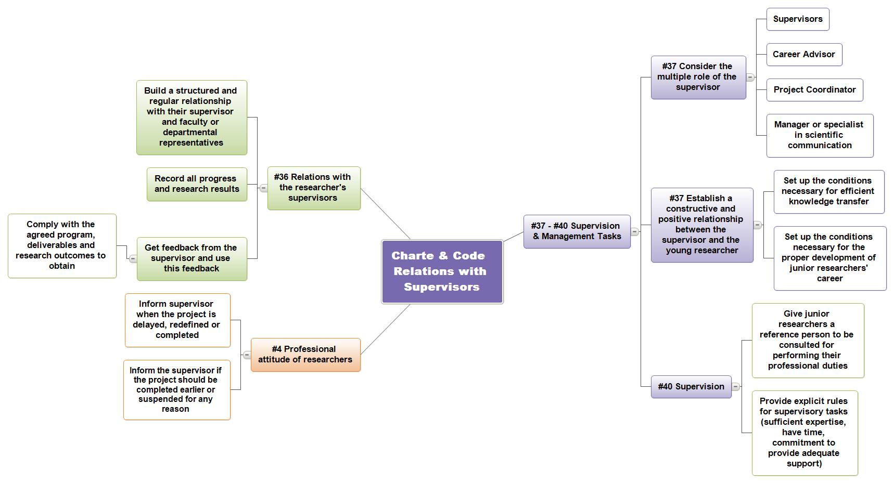

#4. Professional attitude (Charter). Researchers should be familiar with the strategic goals governing their research environment and funding mechanisms, and should seek all necessary approvals before starting their research or accessing the resources provided. They should inform their employers, funders or supervisor when their research project is delayed, redefined or completed, or give notice if it is to be terminated earlier or suspended for whatever reason.

#36. Relation with supervisors (Charter). Researchers in their training phase should establish a structured and regular relationship with their supervisor(s) and faculty/departmental representative(s) so as to take full advantage of their relationship with them.
This includes keeping records of all work progress and research findings, obtaining feedback by means of reports and seminars, applying such feedback and working in accordance with agreed schedules, milestones, deliverables and/or research outputs.
#37. Supervision and managerial duties (Charter). Senior researchers should devote particular attention to their multi-faceted role as supervisors, mentors, career advisors, leaders, project coordinators, managers or science communicators. They should perform these tasks to the highest professional standards. With regard to their role as supervisors or mentors of researchers, senior researchers should build up a constructive and positive relationship with the early-stage researchers, in order to set the conditions for efficient transfer of knowledge and for the further successful development of the researchers’ careers.

#40. Supervision (Charter). Employers and/or funders should ensure that a person is clearly identified to whom early-stage researchers can refer for the performance of their professional duties, and should inform the researchers accordingly.
Such arrangements should clearly define that the proposed supervisors are sufficiently expert in supervising research, have the time, knowledge, experience, expertise and commitment to be able to offer the research trainee appropriate support and provide for the necessary progress and review procedures, as well as the necessary feedback mechanisms.

Law & regulations | Institutional Regulation and Practise | Actions
- Doctoral regulations of the Académie universitaire ‘Louvain’, 2005  sets the minimum standard of duty of the thesis Director and the accompanying committee | - Status of scientific staff paid through operational budgets  Art. 31 “All research performed by a member of the scientific staff benefits from effective scientific leadership. The Department or Unit will, depending on the area of research, assign an academic or scientific staff member who is responsible for monitoring and promoting the research underway.”  - Status of academic staff  Art. 20  “.. The supervision of doctoral candidates is under the effective and principle responsibility of a member of the academic staff. If requested by a Faculty, the Rector can permit the holder of a permanent FNRS contract to assure these responsibilities; similarly, a works supervisor (1) can be given the responsibilities by the Faculty Council. In these two cases however, the promoter will ensure the prior agreement of the academic head of the unit and the Director of department for the thesis topic. ”  Art. 23 Deals with the role of the academic mentor.  “Members of the academic staff will ensure the management and training of their scientific collaborators, members of the scientific staff, in order to provide them with the qualifications necessary for their continued career. In particular, they will assure that the fruit of the professional work of their collaborators is recognized.”  - Regulation of scholarships at the University of Namur (service note 115 reviewed by Board of Directors Meeting n ° 596 27/08/10): regulation determining the conditions under which the University of Namur shall grant a doctoral fellowship.  - Social sector - Workshop for doctoral candidates on their experience and impressions in properly carrying out their research work and on their relations with their supervisors: listening workshops and psychological assistance, support in stress management. Initiative launched in October 2012.  - In French, “chef de travaux”. He is a teaching assistant (equivalent to a professor assistant). | The doctoral regulation does not include the "research assistants" and provides no specific provisions regarding the allocation of their duties as regards teaching and research.  Actions  - Project Axel 8.18 Sets up a "well being" policy for collaborators and works to make the campus a space of development and self realization.  - Establish benchmarks of current practice in other Belgian and foreign universities to improve the policy of the University of Namur  - Set up specific training for supervisors in project and HR management.  - Establish an information process for supervisors for guidance services for PhDs, particularly for their professional insertion.  - Implement a contract between the supervisor and the doctoral student a doctoral contract that determines the duties of doctoral students and their supervisors. This doctoral contract will incorporate the provisions of the Charter and the Code notably the principles #4, 36, 37 and 40. It will also determine the rules apportioning the time between teaching and research activities for research assistants.  - Establish and perpetuate a listening and mediation space for researchers (see workshop set up by the social sector in October 2012).  - Review scholarships regulations at the University of Namur.  - Review the text of the doctoral scholarships convention.  - Translate into English the regulations for awarding scholarships and the doctoral scholarships convention.  - Put in place a procedure that ensures the use of both French and English in official emails relating to researchers contracts or agreements.

  - Career development

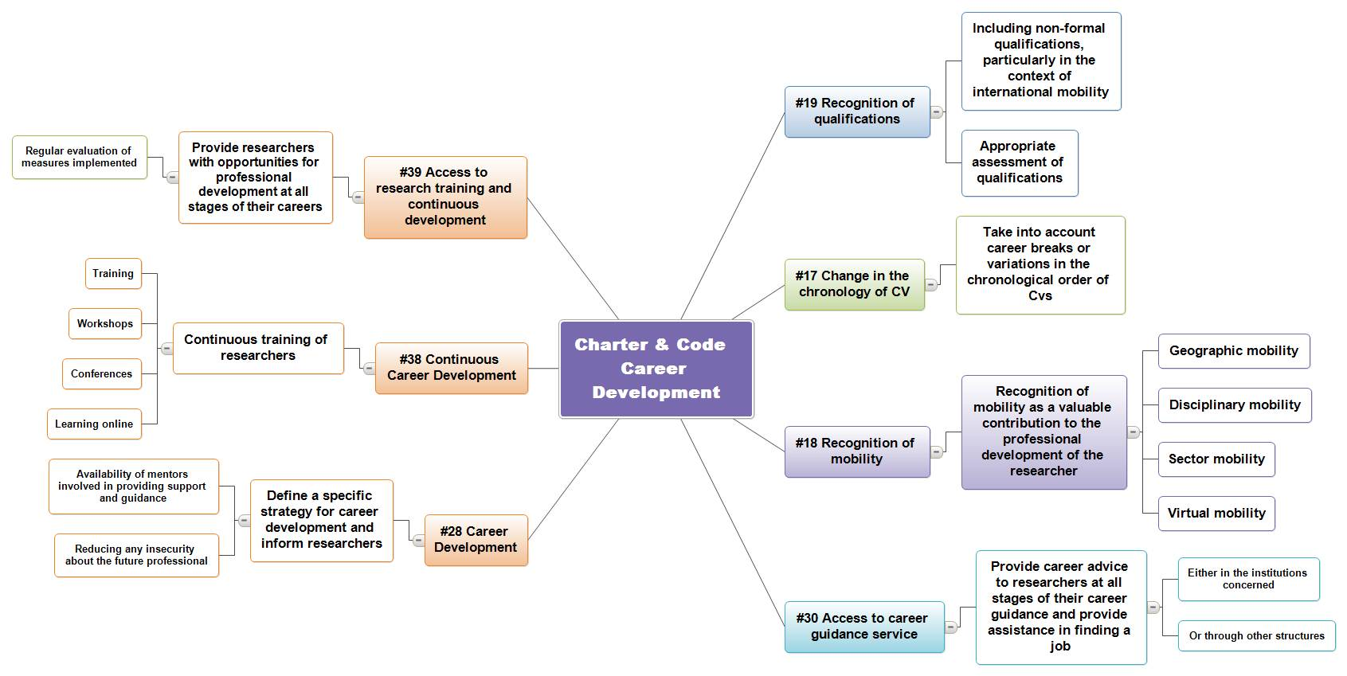

#17. Variations in the chronological order of CVs (Code). Career breaks or variations in the chronological order of CVs should not be penalised, but regarded as an evolution of a career, and consequently, as a potentially valuable contribution to the professional development of researchers towards a multidimensional career track. Candidates should therefore be allowed to submit evidence-based CVs, reflecting a representative array of achievements and qualifications appropriate to the post for which application is being made.
Law & regulations | Institutional Regulation and Practise | Actions
 | - Handbook of Recruitment Procedures & Recruitment Charter of the University of Namur, Board of Directors Meeting. 607 of 17 June 2011-  "Art 1. Encouraging mobility and promotions as a way to retain dynamic staff.  While avoiding the trap of inbreeding, particular care should be taken in the evaluation and the treatment given to internal applications." | Objective criteria are more important in the selection of a candidate than any career possible breaks. The guiding principle for recruitment is for no discrimination of any kind whatsoever.  Action :  Green light

#18. Recognition of mobility experience (Code) Any mobility experience, e.g. a stay in another country/region or in another research setting (public or private) or a change from one discipline or sector to another, whether as part of the initial research training or at a later stage of the research career, or virtual mobility experience, should be considered as a valuable contribution to the professional development of a researcher.

#29. Value of mobility (Charter) Employers and/or funders must recognise the value of geographical, intersectoral, inter- and trans-disciplinary and virtual mobility as well as mobility between the public and private sector as an important means of enhancing scientific knowledge and professional development at any stage of a researcher’s career. Consequently, they should build such options into the specific career development strategy and fully value and acknowledge any mobility experience within their career progression/appraisal system.
This also requires that the necessary administrative instruments be put in place to allow the portability of both grants and social security provisions, in accordance with national legislation.
Law & regulations | Institutional Regulation and Practise | Actions
- Regulation of the National Fund for Scientific Research (FNRS), 2012  These regulations lay down the conditions for scholarship grants financed by the fund for PhD students and Post docs whether they are associated with the FNRS or to another research centre.  - Partnership of Wallonia-Brussels for researchers, May 26, 2011  "Action 4 – Improve information as regards services to researchers, especially researchers in situations of mobility". | - Handbook of Recruitment Procedures & Recruitment Charter of the University of Namur, Board of Directors Meeting. 607 of 17 June 2011-  Art 1. “Encouraging mobility and promotion as a way to retain dynamic staff. While avoiding the trap of inbreeding, particular care should be taken in the evaluation and the treatment given to internal applications."  In the selection process the mobility candidates have demonstrated is a decisive criterion, whether this mobility took place during their initial training or during the early years of their research career.  - Status of academic staff  Art.14. - "A member of the academic staff of another Belgian or foreign University, can be granted a teaching status at the University of Namur.". They will have the title Visiting Professor or Visiting Lecturer, according to their status at their home University"  Art.24. - "All academic staff members are entitled to receive long-term leave for a scientific mission released from their duties to devote themselves to study, scientific research or the synthesis of their work... The financial arrangements are established by mutual agreement between the Board of Directors and the person concerned, the board ensures the maintenance of the financial benefits of academic staff's status.  During the scientific mission, academic staff members retain their function.... "  Annex V - Overall institutional guidelines for a policy on long-term scientific missions  - Status of scientific staff paid through operational budgets  Article 40: "Seniority includes the period(s):  Seniority scientific is also acceptable for scientific activity recognized by the Board of Directors during which the interested party was the recipient of a payment or grant by:  b.1. the Belgian Government, an international organization recognized by Belgium or another country bound to Belgium by a cultural agreement, under this agreement;  b.2. the provinces, the municipalities, the FNRS, as well as all other services or research agencies or funding of scientific research, in accordance with the ministerial decrees in force;  b.3. a university or a foreign scientific institution, upon decision of the Board of Directors.  The recognition of seniority acquired outside the University of Namur assumes that the interested party has provided proof of this seniority ".  Article 60: "The holders of a foreign diploma must have it recognized according to the established regulations."  Article 72: Included in the service activity:  'The periods of scientific missions carried out in Belgium or abroad in the direct interests of the service, with the approval of the Board of Directors and not requiring the replacement of the interested party for the length of their absence"  Article 80: “The leave of absence for a special mission is granted by the Board of Directors only for missions carried out with the assistance of the Belgian government or offered by a foreign government, an international organization recognized by the Belgian government or a university or foreign foundation. This leave of absence is granted when the length, importance or nature of these missions cannot be reconciled with the normal exercise of the main activities and requires their replacement of the interested party during their absence.  The mission must have the consent of the Faculty concerned.  Article 81: "The decision for a leave of absence for a special mission will determine the length of the leave of absence and, if applicable, provide a stipend which may not exceed one-third of the most recent salary. The interested person can be allowed to participate in the advancement of the framework. " | In the context of support to basic research and international exchange, the Board of Directors of the University of Namur each year provides several postdoctoral fellowships to researchers in a situation of international mobility.  Conversely, it encourages its researchers to do internships abroad. This is especially true for academic staff that is encouraged, including with financial incentives, to take on long term scientific missions (two to six months). This can also be done (more rarely) with permanent scientific staff.  When an academic staff member leaves the University of Namur, the institution makes every effort to allow the transfer of research agreements so that researchers can move with their promoter.  Actions :  - Report on mobility: Why? How? When? For who?  Study and reflection on the issue of mobility. In this context, the following aspects should be analyzed:  - What are the objectives of mobility? What are its uses and merits?  - What are the forms of mobility promoted (it should be noted that the C & C envisages 4 forms of mobility: geographical, sectoral, inter-disciplinary and virtual)?  - In what cases is mobility made obligatory or simply recommended?  - Is the recognition of mobility subject to conditions of duration (ex: only mobility of a year without discontinuity is recognized as a mobility experience or can it be split into several periods?)  - Should practices be standardized from one faculty to another?  - Based on this report, clearly identify the University of Namur's mobility policy, including its financial aspects.  - Project Axel 9.25 "Insert the University in the international networks "  - Project Axel 8.20" Maintain structural cooperation efforts with the South".  - Increase the clinks between the administrative departments (Research Administration, International Relations, Human Resources and the Euraxess Rights services). This action is related to the AXEL project 5.12 technical and operational collaboration of administrative services  - To promote the entry of foreign researchers in the University of Namur, to increase the international visibility of the website.

#28. Career development (Charter) Employers and/or funders of researchers should draw up, preferably within the framework of their human resources management, a specific career development strategy for researchers at all stages of their career, regardless of their contractual situation, including for researchers on fixed-term contracts. It should include the availability of mentors involved in providing support and guidance for the personal and professional development of researchers, thus motivating them and contributing to reducing any insecurity in their professional future. All researchers should be made familiar with such provisions and arrangements.
Law & regulations | Institutional Regulation and Practise | Actions
- Partnership of Wallonia-Brussels for researchers, May 26, 2011, Action 9, 20 to 24 , 26 mai 2011  - Decree of July 19, 1991 on the career of researchers , Chap II - Scientific careers, (M.B. 26.09.1991)  This chapter deals with the procedures for recognition of qualifications | - Status of scientific staff paid through operational budgets  Art.10: The Head of the Department / Service ensures the quality and recognition of the work of the visiting scientists attached to their department or service. The scientists receive help and advice from their Head of department or service. They must be informed of the problems in the performance of their duties; in the event that these faults are such as to call into question the renewal of their mandate, the scientist must to be notified in writing as soon as possible.  Art. 18 and 19 relating to educational tasks mention the mentorship of the course holder.  Art. 31 All research by a member of the scientific staff benefits from effective scientific leadership. The Department or Unit will, depending on the area of research, assign an academic or scientific staff member who is responsible for monitoring and promoting the research underway.  Art 50 (and Annex II), art. 52, Art 58 to 64 on the evolution of the career  These articles regulate the career development of scientific staff  - Status of academic staff - Chap. III Career  Art. 13 to 15 regard the allocation of the teaching load to a member of the scientific staff, to a holder of an FNRS mandate or an academic of another Belgian or foreign university, or that is not scientific or academic staff member.  Art. 23 deals with the role of the academic mentor.  "Members of the academic staff will ensure the management and training of their scientific collaborators, members of the scientific staff, in order to provide them with the qualifications necessary for their continued career. In particular, they will assure that the fruit of the professional work their collaborators is recognized. In particular, they should ensure that the fruit of the intellectual work of their collaborators is recognized."  Appointments, Art 31, 32 - Promotion, Art 39 to 43 and Annexes VI (promotion to the rank of Professor) and VII (promotion to the rank of Full Professor  These articles regulate the career development of academic staff.  - The institution is sensitive to these issues. Thus, researchers who fulfil the legal conditions are allowed to introduce a request for qualification (decree 1991) to the French Community of Belgium.  - For FNRS permanent researchers, the University of Namur encourages them to apply for open academic positions. Over the last 15 years, eight FNRS permanent researchers have joined the academic staff of the University of Namur; this represents 44% of all FNRS permanent posts allocated to the University of Namur as of 01/10/12.  - With respect to researchers or teaching assistants on term contracts, the institution strives to facilitate the bilateral termination of the contract whenever they have the opportunity to continue their careers under more stable conditions. Additionally, researchers are encouraged to attend conferences and to present the results of their research. | Actions :  - Project Axel 2.6. "Implement all orientation decided in human resources planning management"  - Make information available on career development and on the individual financing of researchers (mandates, subsidies, etc.) and mobility opportunities. Particular attention is given to information as concerns both the academic career and non-academic career opportunities, from the very start of their research work.

#30. Access to career advice (Charter) Employers and/or funders should ensure that career advice and job placement assistance, either in the institutions concerned, or through collaboration with other structures, is offered to researchers at all stages of their careers, regardless of their contractual situation.
Law & regulations | Institutional Regulation and Practise | Actions
- Partnership of Wallonia-Brussels for researchers, May 26, 2011  Action 3  “Publish online via the European portal Euraxess Jobs, as well as doctorat.be, all university vacancies, scholarships and mandates of the F.R.S.- FNRS as well as those of other actors in the research field.”  - Law of 3 July 1978 on employment contracts, (M.B. 22.08.1978)  Chap. IV The end of the employment contract - Article 37§1 and Art .40§1 Art. 39 Treats the termination of a contract's term while the Art. 40 refers to a fixed term contract. | - Employment unit whose mission is to inform and assist students, former students and researchers in their professional (re)orientation. This unit provides various services:  - Placement Service: the service disseminates job offers (internal and external) through various means(bulletin boards, email, job lists or the TerraNostra intranet  - Support service: personalized assistance for professional (re)orientation: skills assessment, definition of a professional project, writing a CV, a cover letters, tips and simulation for the job interviews in French and English, search of offers adapted to the profile, etc.  - Information service: providing documentation on the world of work, the labour market, etc.  - Status of scientific staff paid through operational budgets - Annexe III  This annex refers to the departure of a member of the scientific staff before the end of his/her contract. The University of Namur is normally aligned with the law. However, for staff under term contracts, derogations are possible under certain conditions.  “However, the Board of directors can at the time of their resignation grant to members of the scientific staff exemptions from the legal provisions. These exemptions can be granted only on the basis of a favourable report of the Dean and the Head of Department to which the interested party belongs. It will be subject of a written agreement.”  - Project Prodoc  The University of Namur is a partner of the European project PRODOC, funded under Interreg. This project aims at the professional insertion of PhDs and young researchers in the cross-border area of Nord-Pas-de-Calais/ Hainaut-Namur. It also helps to better position the doctoral training of the cross-border area on the European and international scene. | Actions:  - Extend the PRO-DOC project  - Conduct an information campaign within the institution to publicize the employment cell and the initiatives taken in the context of the sustainability of PRO-DOC, determine the frequency of this type of campaign and define the most appropriate information channels.

#38. Continuing Professional Development (Charter) Researchers at all career stages should seek to continually improve themselves by regularly updating and expanding their skills and competencies.
This may be achieved by a variety of means including, but not restricted to, formal training, workshops, conferences and e-learning.

#39. Access to research training and continuous development (Charter) Employers and/or funders should ensure that all researchers at any stage of their career, regardless of their contractual situation, are given the opportunity for professional development and for improving their employability through access to measures for the continuing development of skills and competencies.
Such measures should be regularly assessed for their accessibility, takeup and effectiveness in improving competencies, skills and employability.
Law & regulations | Institutional Regulation and Practise | Actions
- Partnership of Wallonia-Brussels for researchers, Action 9, 20 to 24, May 26, 2011  - Decree of 30 March 2007 concerning various measures around research in academic institutions governing the Special Research Funds and research concerning concerted actions; C. III - Funding of the training of researchers in industry and agriculture (M.B. 4.07.2007)  - Doctoral regulations of the Académie universitaire ‘Louvain’, approved by the Council of the Academy, May 9, 2005. (version18/06/2012 )  This Regulation determines the general framework of courses for doctoral students and in particular the rules for assessing the thesis work  - Decree of July 19, 1991 on the career of researchers , Chap II - Scientific careers, (M.B. 26.09.1991)  This chapter deals with the procedures for recognition of qualifications | - Status of scientific staff paid through operational budgets  Art. 15 - "The distribution of these tasks is determined..., by what best advances the training of the scientific staff member "  Art 19 - "To properly carry out their educational duties, the members of the scientific staff must be able to benefit from educational training"  Art 50 (and Annex II), Art. 52, Art 58 to 64 on the evolution of the career  These articles regulate the career development of scientific staff.  - Status of academic staff - Chap. III Career  Art. 13 to 15 regard the allocation of the teaching load to a member of the scientific staff, to a holder of an FNRS mandate or an academic of another Belgian or foreign university, or that is not a member of the scientific or academic staff.  Art 31, 32 & Art 39 to 43. These articles regulate the career development of academic staff.  - Department Education and technology  Development of professional skills exercised in the teaching profession and development of services oriented to the improvement of the quality of learning and teaching. | The university is perfectly suited for each member to fully take advantage of its infrastructure (library, computer networks, language labs ...) and events (conferences, seminars, awards ceremonies...) to advance their own development.  In certain faculties, PhD students are encouraged to organize a "PhD Day" during which a guest speaker is invited to present his/her own experience and give advice to young people.  Actions  - Project Axel 2.5 Strengthen the training policy for personnel and establish a training catalogue.  - Project Axel 2.6 Develop more training in human resources management for all those who have management responsibilities within the university.  - Set up training modules for researchers in project management in collaboration with PRO-DOC  - Set up training modules for teaching collaborators and teaching assistants on teaching techniques and classroom management.  - Set up specific training for supervisors in project management and in HR management.  - Intensify the transversal cross disciplinary training as part of the doctoral programs

  - Teaching and Research tasks
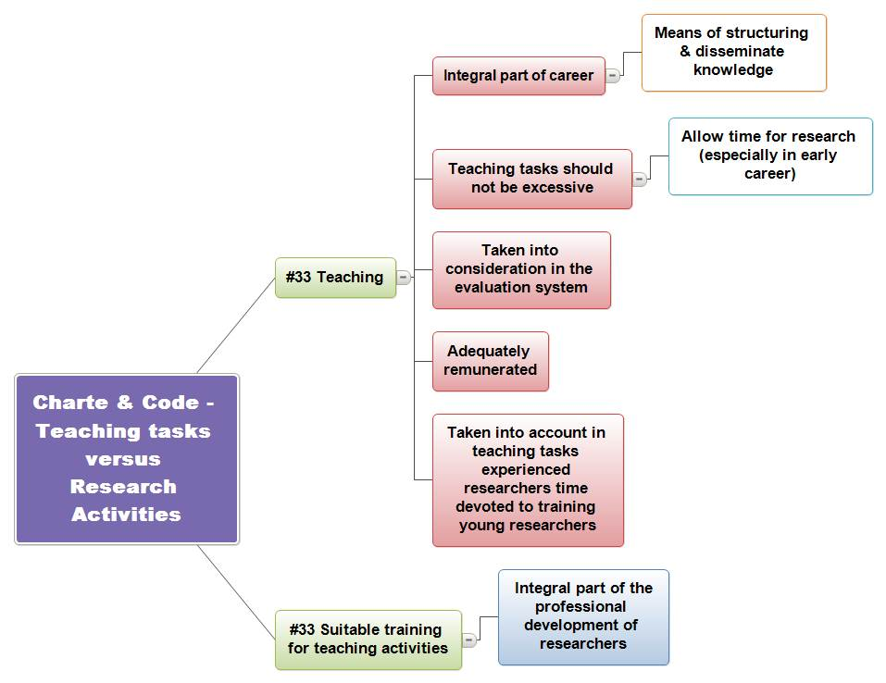

#33. Teaching (Charter) Teaching is an essential means for the structuring and dissemination of knowledge and should therefore be considered a valuable option within the researchers’ career paths. However, teaching responsibilities should not be excessive and should not prevent researchers, particularly at the beginning of their careers, from carrying out their research activities.
Employers and/or funders should ensure that teaching duties are adequately remunerated and taken into account in the evaluation/appraisal systems, and that time devoted by senior members of staff to the training of early stage researchers should be counted as part of their teaching commitment. Suitable training should be provided for teaching and coaching activities as part of the professional development of researchers.
Law & regulations | Institutional Regulation and Practise | Actions
 | - Status of scientific staff paid through operational budgets, Educational tasks, 2.2.1, Art. 14 to 27  The status of scientific staff paid through operational budgets sets the framework for the teaching tasks attributed to this class of researchers in the University of Namur. The following articles specifically address issues in the Charter:  Article 14: Educational tasks, research and service to the community of scientific personnel in a department are determined by the department using procedures approved by the faculty. The distribution throughout the year of the time devoted to these functions by a member of the full-time scientific staff is determined taking into account the needs of the department or service and by the individual's research requirements. However, unless stated explicitly when they are appointed, members of the scientific staff must devote at least half of their time over the year to research.  …  Article 16: Exceptionally, members of the scientific staff may be given only educational tasks. In this case,this is stated explicitly in the contract or as part of the decision when they are appointed.  Article 18: The educational tasks require collaboration between the members of the scientific staff and the person in charge of the course. In this way, they participate in attaining the objectives of the department or service, in particular to those concerned with education. However, when the member of the scientific staff is responsible for giving a specific program or courses, he/she has complete freedom to complete it.  Article 19: To carry out their educational activities, members of the scientific staff must benefit from educational training or mentoring through their contacts with person having overall responsibility for the course holders and the resources made available by the institution (methodology courses, seminars,...).  - Status of academic staff - teaching activities Art.17 to 20  Article 18 - Academic staff members are individually or collegially, responsible of one or several courses...  Article 19. - The academic staff assures the education tasks to the level and volume determined by the Board of Directors on the basis of proposals from the department or faculty in charge of the program, based on the number of program hours, the number of students or other parameters specific to the function...  Article 20 -...The supervision of a doctoral student is principally and under the effective control of a member of the academic staff. At the demand of a faculty, the Rector can give the holder of a permanent FNRS contract the right to access these same responsibilities; similarly, a works supervisor(1) can be given the same right by the Faculty Council...  The possibility and the extent of teaching eventually given to a postdoctoral researcher is governed by the regulations in force for the researcher's bursary in the case of postdoctoral researchers receiving institutional funding. By analogy in the case of FNRS researchers, there is no remuneration for these tasks.  - Terms and conditions for the beneficiaries of a postdoctoral fellowship to be authorized to teach. Minutes of the Board of Directors no. 551 of October 20, 2006  In substance, the rules are as follows:  - "the authorization is granted by the research administrator, based on the opinion of the promoter;  - in the event that the teaching exceeds 30 hours, authorization from the Rector is necessary;  - this work will not entitle them to any monetary increase in their fellowship;  - the annual statement of the external services will be forwarded by the thesis promotor to the Board of Directors, to be included in the list of external services declared by the scientific staff."  - Regulations for fellowship bursaries at the University of Namur.  Art - 1 Doctoral student scholarships  Pt 1.4.1. - Time spent on research  "A doctoral scholarship is granted only to someone working full-time in preparation of his/her doctoral thesis. The doctoral student benefiting from a fellowship may be authorized to provide 30 hours of teaching on a voluntary basis."  Art. 2 Postdoctoral fellowships  Pt 2.4.1. - Time spent on research  A post-doctoral fellowship is granted only to someone working full-time on postdoctoral research. "Full time" research excludes any employment or service contract with any natural or legal person. No teaching, mentoring or scientific logistical tasks can therefore be imposed on the recipient of a postdoctoral research fellowship.  However, at their request, the recipient of a postdoctoral research fellowship can carry out educational tasks. Listed here are the conditions under which they may have specific educational tasks and also the number of hours set at 30.  Art. 3. Training Bursaries 3.4. 1. No teaching, mentoring or scientific assistance can be imposed on the scholar "  Researchers paid by a funder other than FRIA or FNRS are generally not allowed to teach under the conditions of the funding organization.  - In French, “chef de travaux”. He is a teaching assistant (equivalent to a professor assistant) | For supervisory staff, practices differ across different faculties and excesses are sometimes seen in the proportion of teaching duties performed.  Actions:  - Standardization of practices within the institution, should take into account the following:  - Establish a weighted mechanism for the type of Group Seminars, the workload may vary;  - Provide a scale of increased workload: a beginner should have a charge lighter than an experienced teaching assistant;  - Take into account the number of students to be supervised;  - Standardize practices among faculties Establish a procedure to ensure that the rules on the balance between teaching and research tasks are followed and regularly inform the promoters of the applicable rules.

  - Evaluation

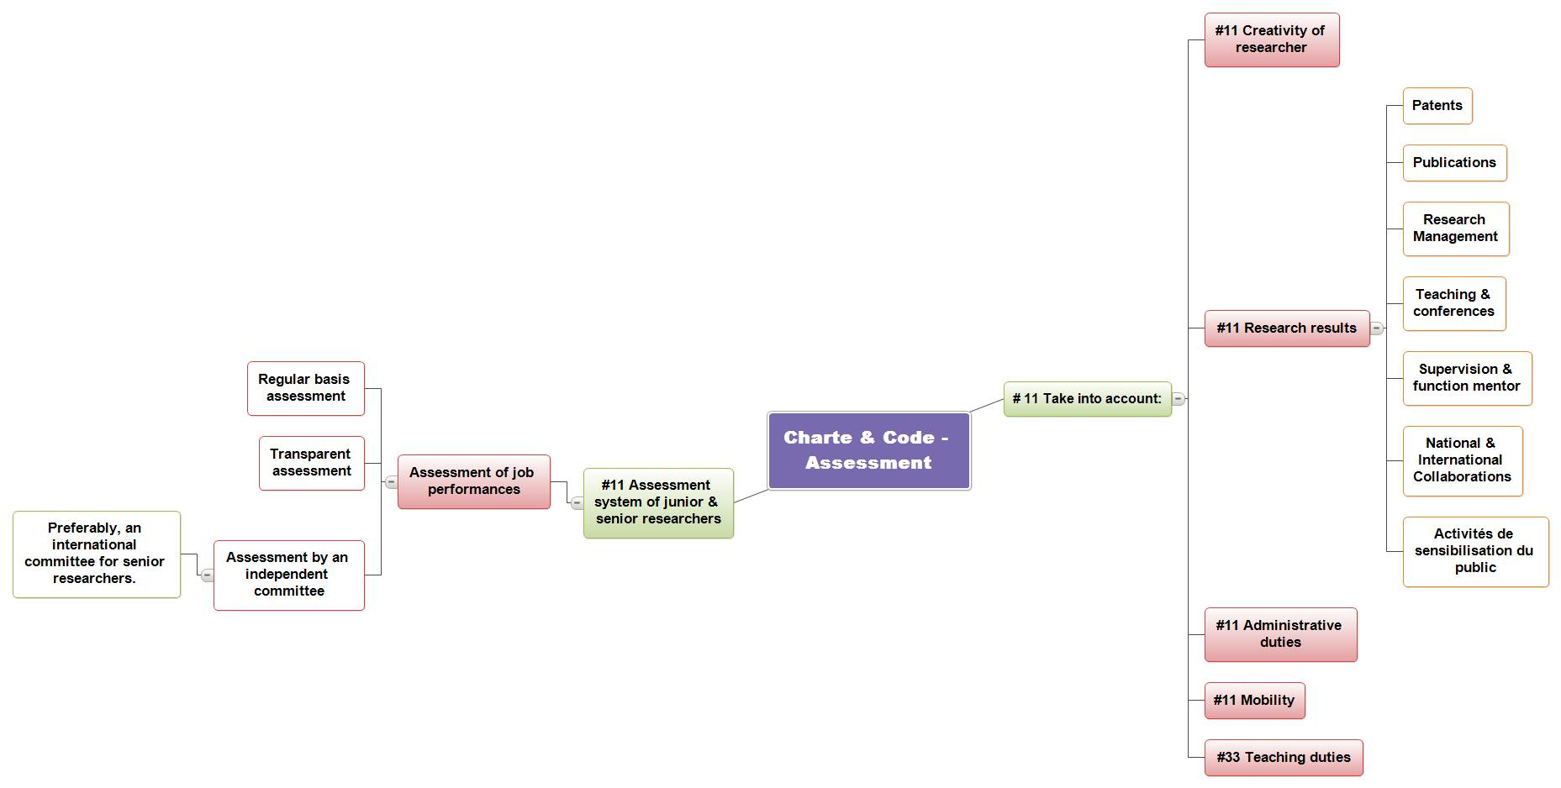

#11. Evaluation/appraisal systems (Charter) Employers and/or funders should introduce for all researchers, including senior researchers, evaluation/appraisal systems for assessing their professional performance on a regular basis and in a transparent manner by an independent (and, in the case of senior researchers, preferably international) committee.
Such evaluation and appraisal procedures should take due account of their overall research creativity and research results, e.g. publications, patents, management of research, teaching/lecturing, supervision, mentoring, national or international collaboration, administrative duties, public awareness activities and mobility, and should be taken into consideration in the context of career progression.

#33. Teaching (Charter) (…) Employers and/or funders should ensure that teaching duties are adequately remunerated and taken into account in the evaluation/appraisal systems, (…)

Law & regulations | Institutional Regulation and Practise | Actions
- Research Strategy 2011 - 2015: Towards an integrated research policy, Minister for Sustainable Development and the Public Service, in charge of Research  7. Evaluation of research and future prospectives  Action Plan 28 - Improvement of procedures for ex-ante evaluation  Action plan 29 - Establishment of an ex-post evaluation procedure  Action plan 30 - Administrative simplification and traceability of given funding aid  - Doctoral regulations of the Académie universitaire ‘Louvain’ approved by the Academic Council, May 9, 2005. (version18/06/2012 )  This regulation determines the general framework of courses for doctoral students and in particular the rules for assessing the thesis  - Decree of July 19, 1991 on the career of research scientists, Chap II - Scientific careers, (M.B. 26.09.1991)  This chapter deals with the procedures for the recognition of qualifications. | - Axel program - Together, let’s build excellence - General Assembly 137 of October 28, 2011  Axis 7 - Engage the university in a process of continuous quality improvement  Involves the regular assessment of our staff, our education and our research...  With respect to the evaluation of staff, we look to combine academic freedom and more generally, the respect due to each member of our community, with a deepening and strengthening of our assessment methods, implementing a culture of positive evaluation, a source of dialogue and not exclusion, based on the definition of known objectives, skill levels to reach and driven by incentives, not exclusion. It will define how this evaluation process can lead the academic staff to a differentiated career over time, allow the members of the scientific staff real follow-up and feedback on the quality of their work and promote within the support staff, institutional mobility.  - Status of scientific staff paid through operational budgets -  Article 20: Except for the provisions in Article 16, the evaluation of a scientific staff member will focus on his/her work as defined in Article 14 without privileging one over the other.  Regarding the renewal of the contract (§3.2.4), there is a sort of self-assessment mechanism for the researcher that is then confirmed by the promoter.  Article 54: At the start of each calendar year, the director of personnel sends each faculty or service a list of mandates expiring at the end of the academic year, as well as the possible confirmations for A rank permanent contract re-appointment as first assistant (in French, “Premier assistant”)  The Dean notifies the researcher concerned as well as the faculty or service concerned.  The researcher prepares a short report regarding the educational tasks, research (including scientific support tasks) and his/her service to the community, the time and physical infrastructure which was required for his/her respective performance, any assistance received for his/her scientific work and all other activities that they had to carry out. They will, if need be, raise the difficulties encountered in the exercise of his/her function which are not his/her direct responsibility. For his/her part, the research promoter or his/her representative, as well as the director of the department or service concerned will each write a report on the work of the researcher.  These reports, in lieu of a graded report, will be signed by the interested parties, who may add their remarks. These reports are forwarded to the dean by the director of the department no later than five months prior to the expiry of the mandate. If they consider it appropriate, the researcher can send a confidential report to the dean.  - Status of academic staff  Annex I 'Mentoring and evaluation of new academics' describes the conditions of the academic contract, continuous assessment and mentoring of the newly appointed academic | Certain statutory provisions are no longer applicable following changes in institutional policy. This is the case for the appointment in the rank A of scientific staff with a permanent contract as first assistant.  Actions :  - Identify the statutory provisions (status of the academic and scientific staff) that need modification to conform to the principles of the Charter and the Code.  - Project Axel 7. 15 Reinforce the evaluation methods of the members of the academic staff.  - Project Axel 7.16 Establishment of an evaluation of the research entities.  - Establishment of a formative individual evaluation of scientific personal to allow:  - Setting operational objectives & timing;  - Evaluating the progress towards the objectives set and the timing;  - "Drive forward" their research activity;  - Considering the balance between teaching and research activities.  The elements of this evaluation could be based on the following tools:  - Evaluate the progress: use evaluation criteria in the contracting process to assess the progress to date and that needed in the future;  - Use a constructive critical approach: provide for appraisal interviews to raise awareness on used strategies and critically reflect on on one’s work.  - Establish a periodic activity report: to take stock of the situation and constitute a reference for future evaluation.  - Take into account the diversity of the work: all tasks of the researcher must be considered in the evaluation, including knowledge transfer activities.

Part 2: Principles that apply to researchers as concerns career management

  - Recrutement & Selection

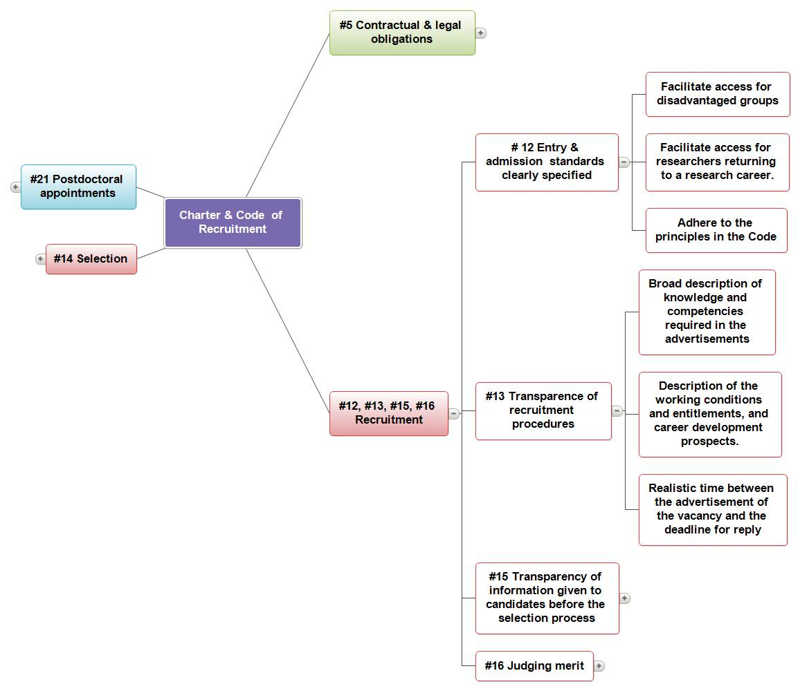

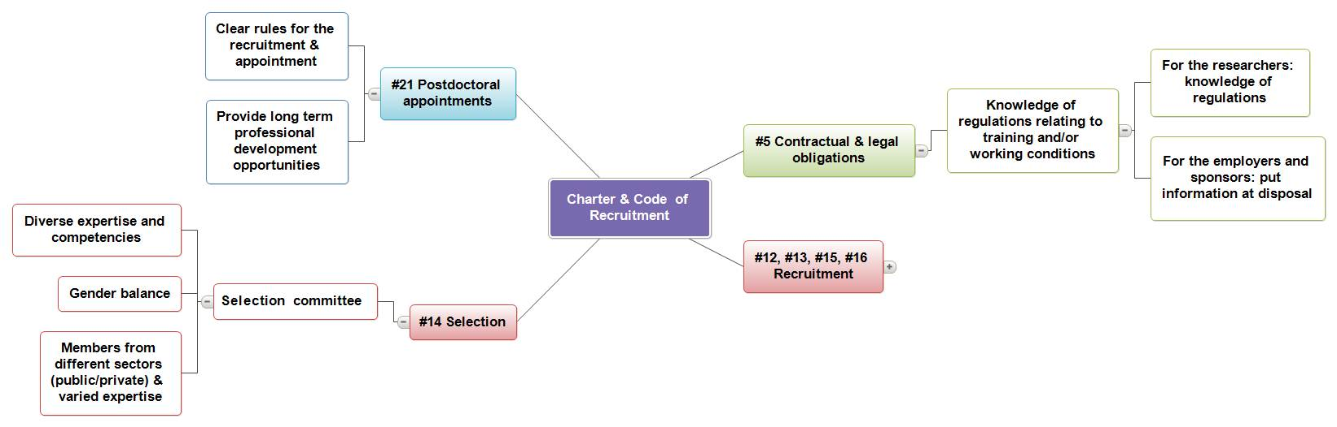

#5. Contractual and legal obligations (Charter) Researchers at all levels must be familiar with the national, sectoral or institutional regulations governing training and/or working conditions.
This includes Intellectual Property Rights regulations, and the requirements and conditions of any sponsor or funders, independently of the nature of their contract. Researchers should adhere to such regulations by delivering the required results (e.g. thesis, publications, patents, reports, new products development, etc) as set out in the terms and conditions of the contract or equivalent document.
Law & regulations | Institutional Regulation and Practise | Actions
See. #12, #13 | - General regulation on ownership, protection and use of the research results of research carried out within the University of Namur (Meeting of the Board of Directors no. 523 of June 28, 2004)  "Art 2. Object  This regulation is designed to lay down rules for ownership, protection and use of results of research conducted at the University of Namur.  Art 3. Scope  This regulation shall apply to all researchers who undertake to comply with the provisions of the terms of their employment contract, their status or the document which they received to this purpose".  - Status of scientific staff paid through operational budgets -  Art. 15 - "The distribution of these tasks is determined..., by what best advances the training of the scientific staff member "  Art 19 - "To properly carry out their educational duties, the members of the scientific staff must be able to benefit from training in educational methodology"  - Laboratory notebooks must be kept 5 years by researchers to insure the traceability of results and reproducibility of experiments. | "TerraNostra" Intranet  The University of Namur has developed an intranet "TerraNostra" where different types of information are published:  - Measures or working practices for professional life  One of the sections, Verbos, includes information relating to the employment contract (insurance, holidays, retirement,...) and practical information (major purchases, medical costs), social (adoption, alcoholism, etc.) and information about the institution.  - Career information specifically for the researcher.  Actions:  - Improvement of the structure of the information on TerraNostra.  - Welcome pack for researchers.  Communication from ADRE (Research Administration)  ADRE provides researchers with all the information relating to research contracts financed by external sponsors.  Actions :  - Create a 'Welcome Pack' incorporating the practices and regulations of the institution, in terms of quality, ethics, intellectual property rights, conditions for training and/or work, health and safety.  Study the most appropriate form of this Welcome Pack to ensure its optimal distribution.  - Organize targeted information sessions for the various departments.

#12. Recruitment (Charter) Employers and/or funders should ensure that the entry and admission standards for researchers, particularly at the beginning at their careers, are clearly specified and should also facilitate access for disadvantaged groups or for researchers returning to a research career, including teachers (of any level) returning to a research career.
Employers and/or funders of researchers should adhere to the principles set out in the Code of Conduct for the Recruitment of Researchers when appointing or recruiting researchers.
#13. Recruitment (Code) Employers and/or funders should establish recruitment procedures which are open , efficient, transparent, supportive and internationally comparable, as well as tailored to the type of positions advertised.
Advertisements should give a broad description of knowledge and competencies required, and should not be so specialised as to discourage suitable applicants. Employers should include a description of the working conditions and entitlements, including career development prospects.
Moreover, the time allowed between the advertisement of the vacancy or the call for applications and the deadline for reply should be realistic.
#15. Transparency (Code) Candidates should be informed, prior to the selection, about the recruitment process and the selection criteria, the number of available positions and the career development prospects. They should also be informed after the selection process about the strengths and weaknesses of their applications.
Law & regulations |  | Institutional Regulation and Practise |  | Actions
- Ministerial Decree of March 31, 2009 laying down the procedures for funding of research activities in the federal scientific institutions under the authority of the Minister of Science Policy (M.B. 14.04.2009)  Chap. II - deals with the recruitment of a researcher in this framework  - Decree of 30 March 2007 concerning various measures around research in academic institutions governing the Special Research Funds and research concerning concerted actions; C. III - Funding of the training of researchers in industry and agriculture (M.B. 4.07.2007)  - Doctoral regulations of the Académie universitaire ‘Louvain’, approved by the Council of the Academy, May 9, 2005. (version18/06/2012 )  This Regulation determines the general framework of courses for doctoral students and in particular the rules for assessing the thesis work.  - Diversity Charter of the Walloon Region  - Decree of 20 July 2000 on urgent measures for higher education and scientific research (M.B. 26.08.2000)  Title IV - provisions relating to scientific research - Chap. I - Funding for training of researchers through bursary programs (FRIA scholarships - funding for research training in industry and agriculture)  Chap. II - bursaries and their conditions.  This component describes the procedures of the FRIA bursaries  - Decree of July 19, 1991 on the career of research scientists (M.B. 26.09.1991)  Statement on the qualification and the remuneration of researchers not paid on the operational budget;  - Act of April 28, 1953, on the Organization of university education by the State (M.B. 1st May 1953)  Chap.III_ teaching staff  Chap. IV - Scientific and administrative personnel  - R.D. of October 31, 1953 (status of scientific and academic staff);  - Partnership of Wallonia-Brussels for researchers, Actions 1, Action 3 May 26, 2011 | - Charter of the University of Namur  "The Humanist and Jesuit heritage is reflected in the University of Namur by a confident openness to the world and a particular attention to humanity. In the spirit of justice, the university attaches a special concern to those that history has left poor, marginalized, or oppressed. Within the university community, this attention to the human being is shown in the respect, trust and recognition of the contribution of each to the common task. "  - Handbook of Recruitment Procedures & Recruitment Charter of the University of Namur, Board of Directors 607 of 17 June 2011-  This is a guarantee of professionalism and respect for the candidates. This Charter requires in particular that those not selected are informed of the reasons for this decision.  It states in part:  “Art 1. Encouraging mobility and promotions as a way to retain dynamic staff. While avoiding the trap of inbreeding, particular care should be taken in the evaluation and the treatment given to internal applications."  "6. Information: all candidates have the right to obtain feedback on their results during the recruitment process.  At the interview, the recruiter must give information on the estimated salary if requested by the applicant. In the same way, any additional information to that mentioned in the announcement must be provided by the people participating in the recruitment process....  8. Diversity: the institution wants to recall that its recruitment policy is driven by a desire for diversity, including a strong will to vary ages, genders and experience.  Any selection using non-work based criteria (religion, age, sex, political opinion, ethnic origin, disability, union membership,...) is not acceptable and must be proscribed."  - Regulation concerning scholarships at the University of Namur (service note 115 reviewed by the Board of Directors n° 596 27/08/10)  Regulation determining the conditions under which the University of Namur shall grant a doctoral or post doctoral fellowship.  - Note of the Vice-Rector of June 21, 2011 on recruitment procedures (version endorsed by the Board of Directors n° 607 of 17/06/2011)  This note sets out ethical and methodological procedures for recruitment through the development of a charter and provides an inventory of recruitment procedures in place by function category.  - Diversity Charter, signed in 2010.  - Intranet - TerraNostra where all documents are made available to staff :  Articles related to status:  - Status of scientific staff paid through operational budgets  Art.6, Art. 46 to 52 on recruitment  - Status of academic staff  Art. 5, Art. 12 to 16 and Annex 6 relating to the conditions and procedures for promotion to the rank of professor  Art. 31 to 38 - deals with appointments to the status of lecturer, associate professor, full professor, and professor extraordinary. It precisely details the procedure from the opening of applications, to the examination of applications and the hiring of the academic.  Art. 39 to 43 deals with the conditions and procedures for promotion. |  | Dissemination of employment offers through various means of communication: The employment unit of the University of Namur ; mailings to alumni announcements sent to other Belgian and international universities; "Euraxess-Jobs" information portal  The employment offers web page also displays the list of positions allotted by internal promotion and provides links to similar sites at the partner universities. In practice, a former researcher has the position once they fulfil the recruitment and selection conditions. Employment postings include a description of the service, the mission, the candidate profile and recruitment procedures, the legal obligations concerning the 'safety issues' of the proposed position, risk analysis of the job, the desired abilities concerning the management analysis of "health and safety" and sustainable development.  The signature of the employment contract is often tardy and the researchers are not always informed of the working conditions and pay scales before beginning work.  Actions:  - Work rules  - Welcome and "health and safety".  - Harmonize regulations for statutory and non-statutory staff.The objective is to develop a set of common procedures and practices to comply with the legal requirements and to ensure greater transparency for researchers.  - Review recruitment procedures so that they are in compliance with the standards of the Charter and the Code (in particular, those relating to temporary scientific staff and fixed-term teaching assistants).  - Ensure maximum transparency as regards the employment contract, including information on working conditions and salary for the researcher before their recruitment. This transparency presupposes the signature of the employment contract before the start of the researchers work in the service under a fixed-term contract. For people under permanent contracts, it assumes they are at least informed of the principle elements of the employment contract of such as pay, working hours, and fringe benefits.  - Create a communication unit responsible to welcome researchers and inform them about the regulations (legislation and institutional practices) of any matter related to HR  - Integrate on the web site a page devoted to information on the working conditions, rights, career development possibilities and in particular: entry standards, types of researchers with the payment scales and procedures which govern their career, candidature evaluation methods, and general information on working conditions in the institution.  - Publication of the application forms in both English and French  - Translate employment contracts into English  - Develop a protocol to welcome foreign researchers in English at the signing their employment contract.  - Publication of research employment offers on Euraxess Jobs. With this in mind, modify the procedures to make this publication more systematic and in particular:  - improve the process of transmission of employment offers from the departments and/or services to the employment cell.  - ensure the translation of employment offers in English.

#14. Selection (Code) Selection committees should bring together diverse expertise and competences and should have an adequate gender balance and, where appropriate and feasible, include members from different sectors (public and private) and disciplines, including from other countries and with relevant experience to assess the candidate. Whenever possible, a wide range of selection practices should be used, such as external expert assessment and face-to-face interviews. Members of selection panels should be adequately trained.
Law & regulations | Institutional Regulation and Practise | Actions
Partnership of Wallonia-Brussels for researchers, Actions 1, Action 3 May 26, 2011 | - Handbook of Recruitment Procedures & Recruitment Charter of the University of Namur, Board of Directors 607 of 17 June 2011- Practicalities  “... all recruitment must involve 2 or more people, not including the Human Resources department."  - Missions of the Research Council for institutional scholarships  For bursaries given by the University of Namur, the Research Council operates as the selection committee. It is composed of 19 members from both the academic and scientific community, as well as directors of the research administration (ADRE) and external relations administration. When it is possible to meet with the candidates, a face-to-face interview is sometimes conducted.  - Status of scientific staff paid through operational budgets  Art.6, Art. 46 to 52 on recruitment  - Status of academic staff  Art. 5, Art. 12 to 16 and Annex 6 relating to the conditions and procedures for promotion to the rank of professor  Art. 34 very clearly describes the procedure in the matter of review of the applications, which are referred to a commission. | Selection practices differ based on the posts and faculties, but also by the people under whose responsibility the recruitment is done.  Actions:  - Ensure a gender balance in the establishment of recruitment committees.  - Put in place the systematic use of report/minutes of the recruitment procedure for any type of position. To this end establish a report form in accordance with the principles of the Charter and the Code.  - Reflect on standardizing selection practices within the various departments and faculties to define the selection policy of the institution.

#16. Judging merit (Code) The selection process should take into consideration the whole range of experience of the candidates. While focusing on their overall potential as researchers, their creativity and level of independence should also be considered.
This means that merit should be judged qualitatively as well as quantitatively, focusing on outstanding results within a diversified career path and not only on the number of publications. Consequently, the importance of bibliometric indices should be properly balanced within a wider range of evaluation criteria, such as teaching, supervision, teamwork, knowledge transfer, management of research and innovation and public awareness activities. For candidates from an industrial background, particular attention should be paid to any contributions to patents, development or inventions.
Law & regulations | Institutional Regulation and Practise | Actions
- Partnership of Wallonia-Brussels for researchers, Actions 1, Action 3 May 26, 2011 | All criteria are used for the analysis of candidate researcher (see the variety of evaluation criteria published in the employment offers).  For the recruitment of PhD candidates, bibliometric data is most often not relevant; it is the academic career and training which are the decisive factors.  For the recruitment of post doctorates: The list of publications intervenes more directly. | Actions :  - Complete the handbook of recruitment procedures and the recruitment charter of the University of Namur including the requirements of the Code of conduct for the Recruitment of Researchers as concerns judging merit and mobility in particular  - Review the application forms used for scientific and acadethemic positions in light of the criteria put forward in the Charter and the Code in terms of mobility, recognition and judging merit.

#21. Postdoctoral appointments (Code) Clear rules and explicit guidelines for the recruitment and appointment of postdoctoral researchers, including the maximum duration and the objectives of such appointments, should be established by the institutions appointing postdoctoral researchers. Such guidelines should take into account time spent in prior postdoctoral appointments at other institutions and take into consideration that the postdoctoral status should be transitional, with the primary purpose of providing additional professional development opportunities for a research career in the context of long term career prospects.
Law & regulations | Institutional Regulation and Practise | Actions
- Regulation of the National Fund for Scientific Research (FNRS), 2012  These regulations lay down the conditions for scholarship grants financed by the fund for PhD students and Post docs whether they are associated with the FNRS or to another research centre.  - Decree of 19 July, 1991 concerning the career of researchers, Chap II – Scientific careers, M.B. 26.09.1991  This decree deals with researchers who are not paid through operating allocations to universities. Articles 4 to 16 treat scientific careers. The postdoctoral careers are specifically referred to in articles 11 to 16. | - Regulation concerning bursaries at the University of Namur (service note 115 reviewed by the meeting Board of Directors n° 596 27/08/10)  Regulations determining the conditions under which the University of Namur shall grant a doctoral or post doctoral fellowship.  - Approval of the University of Namur to facilitate the arrival of fellowship post doctorates from outside the EU (the research administration ADRE provides a hosting agreement)  - Documentation available on the intranet TerraNostra concerning the hosting of foreigner researchers  - Existence of a Post doctorate Fellowship agreement, signed by the researcher.  - For Marie-Curie EU projects, preparation of a framework grant agreement (in English), in addition to the standard bursary convention, for the European Commission  - University of Namur-CERUNA post doctorate research fellowship programme  This program fixes very precisely the regulation for obtaining a postdoctoral fellowship  For example, the program for the academic year 2012-2013 sets out the following:  Target: internationally mobile researchers (who have not lived in Belgium more than 24 months in the last 3 years)  Qualifications: PhD with thesis obtained after the 09.01.06 and before the 01.09.12. The candidate may not have benefited from a Belgium Postdoctoral Fellowship for more than 24 months and cannot have been more than six months at the University of Namur at the date of submission. Duration: one year (necessarily 12 consecutive months) with the possibility of an extension for a second year without interruption;  It also specifies the expenses covered, the recruitment methods and work entailed by the mission. | Actions:  - Provide support to "post-doctoral" candidate to improve the postdoctoral experience and to avoid any continuing precarity of the candidate's situation (action to consider with the continuation of PRODOC under principle #30).  - Review post-doctoral scholarship regulations at the University of Namur.  - Review the post-doctoral scholarship agreement.  - Translate the post-doctoral scholarship regulations and agreement into English  - Set up a procedure that ensures the use of both French and English in official emails relating to researchers contracts or agreements  .

  - Working conditions

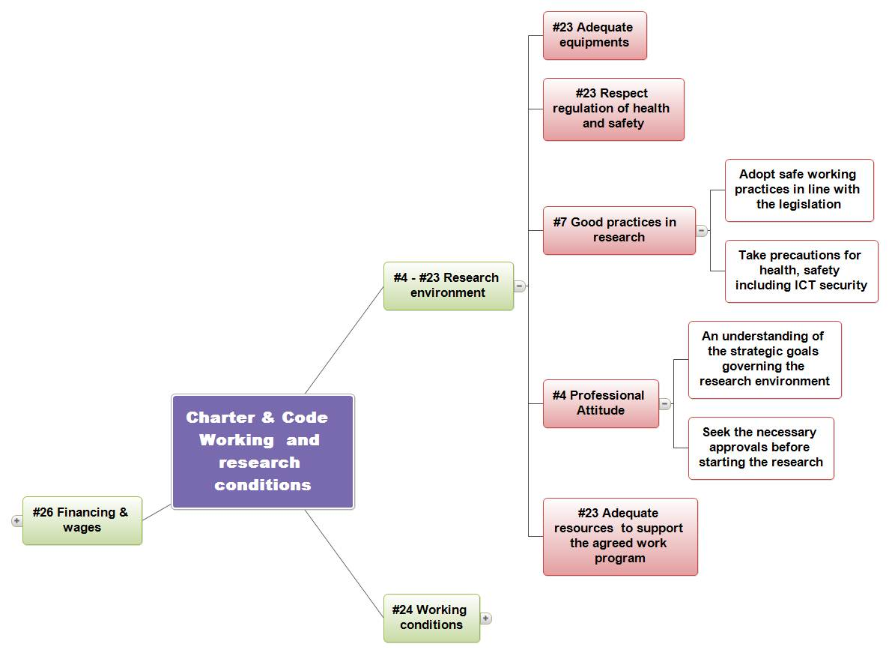

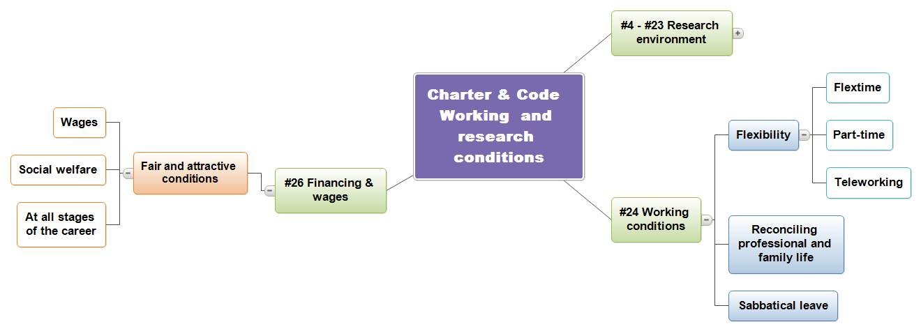

#4. Professional attitude (Charter) Researchers should be familiar with the strategic goals governing their research environment and funding mechanisms, and should seek all necessary
approvals before starting their research or accessing the resources provided.
They should inform their employers, funders or supervisor when their research project is delayed, redefined or completed, or give notice if it is to be terminated earlier or suspended for whatever reason.
Law & regulations | Institutional Regulation and Practise | Actions
- FRS-FNRS, Code of ethics for scientific research in Belgium (D/2009/1191/6)  - Legal measures and decrees regulating the financing of research  Information available from the sponsors (websites, contact,...) | - Status of scientific staff paid through operational budgets - Art. 9  "As a full member of the faculty, department, service or unit to which he/she is attached, the research scientist... is involved in the development of research programs and the budgetary management of the faculty, department, service, or unit. By budgetary management is meant, access to information on budgets, accounts"  - Academic staff status- Art. 22  Art.22. - All members of the academic staff are free to conclude and sign outside  research contracts... The approval and signature of the Rector are required if the contract requires it or envisages the hiring of staff. | Information about funding mechanisms is included on the University of Namur web site in the funding research section.  www.FUNDP.ac.be/recherche/services/financement  In addition, the research administration (ADRE) communicates to the promoter the funding conditions and a copy of the conventions with the funder.  Action :  Green light

#7. Good practice in research (Charter) Researchers should at all times adopt safe working practices, in line with national legislation, including taking the necessary precautions for health and safety and for recovery from information technology disasters, e.g. by preparing proper back-up strategies. They should also be familiar with the current national legal requirements regarding data protection and confidentiality protection requirements, and undertake the necessary steps to fulfil them at all times.

#23 Research environment (Charter) Employers and/or funders of researchers should ensure that the most stimulating research or research training environment is created which offers appropriate equipment, facilities and opportunities, including for remote collaboration over research networks, and that the national or sectoral regulations concerning health and safety in research are observed. Funders should ensure that adequate resources are provided in support of the agreed work programme.
Law & regulations | Institutional Regulation and Practise | Actions
- FRS-FNRS, Code of ethics for scientific research in Belgium (D/2009/1191/6)  Biosecurity  - Decree of the Walloon Government of 4 July 2002 determining the conditions by sector relating to uses of confined genetically modified or pathogenic organisms (M.B. 21.09.2002)  - Decree of 11 March 1999 on environmental permits (M.B. 08.06.1999)  Privacy  - Law of 8 December 1992 on the protection of privacy with regard to the processing of personal data, (M.B. 18 March 1993)  Rules of conduct for the use of IT tools  - Collective Labour Agreement No. 81 of 26 April 2002 on the protection of worker privacy with respect to the control of electronic communication data in networks  - Act of 28 November 2000 relative to ‘computer crime‘, (M.B. 03.02.2001)  - The Privacy Protection Commission, initiative opinion on the monitoring of the use of the computer systems in the workplace by the employer, March 4, 2000 (10/IP/2000/017)  - Law of 8 December 1992 on the protection of privacy with regard to the processing of personal data, (M.B. 18 March 1993)  R.D. of March 27, 1998 relating to the policy of worker welfare during the execution of their work (M.B. 31.3.1998) and all decrees of execution that modify it: this is the reference as regards health and safety at work.  General principles  - Measures relating to the monitoring of workers health (SEPPT) [R.D. 28.05.2003]  - Measures relating to the psycho-social issues relating to the work (SEPPT) [R.D.17/05/2007]  - First aid [R.D. 12.15.2010)  Organizational structures  - Internal service for health and safety at work (SIPPT) [R.D. 1998.03.27]  - The external service for health and safety at work [R.D. 1998.03.27]  - External service for technical inspections in the workplace (SECT) [R.D. 29.04.1999]  - The committees for health and safety at work (CPPT) [R.D. 3.05.1999]  - Superior Council for health and safety at work (CPPT) [R.D. 7.10.2006 ]  - Training and retraining of health and safety advisers [R.D. 17.05.2007]  - Internal service for health and safety at work [R.D. 27.10.209]  Workplaces: and in particular the following measures:  - Security and health signs at work [R.D. 17/06/1997]  - Protection of workers against tobacco smoke. see 'Chapter 4. -Prohibition of smoking in the workplace ' the Act of 22 December 2009 establishing a general regulation banning smoking in enclosed places accessible to the public and the protection of workers from tobacco smoke  - Electrical installations [R.D. 02.06.2008]  - Social facilities  - Specific work environments  - Lead-acid batteries  - Workplaces that may contain hazardous gases  - Stocking flammable liquids [R.D. 1998-03-13]  - Areas presenting risks due to potentially explosive atmospheres [R.D. 26.03.2003]  - Work in hyperbaric environments (R.D. 23.12.2003)  Environmental factors and physical agents  - Ventilation of work areas  - Thermal environments [R.D. 4.06.2012]  - Noisy environments [R.D.16.01.2006]  - Vibrations [R.D. 07.07.2005]  - Artificial optical radiation [R.D. 04.22.2010]  - Non-ionizing radiation  - Ionizing radiation [R.D. 25.04.1997]  Chemical, carcinogenic, mutagenic and biological agents  - Chemical agents [R.D. 11.03.2002]  - Carcinogenic and mutagenic agents [R.D. 2.12.1993]  - Biological agents [4.08.1996]  - Specific provisions concerning asbestos [R.D. 16.03.2006]  Tools and equipment: General provisions [R.D. 12.08.1993], display screens [R.D. 27.08.1993], of work station seats and resting seats [R.D. 27.04.2004]  And if required by some researchers:  - Mobile work equipment and equipment for lifting loads [R.D. 4.05.1999]  - Equipment for temporary work at height [R.D. 31.08.2005]  Personal equipment: Work clothes [R.D. 06.07.2004], personal protection equipment [R.D. 13.06.2005]  Specific categories of workers and special situations  - Maternity protection [R.D. 2.05.1995]  - Specific measures concerning violence, bullying or sexual harassment in the workplace [R.D. 11.07.2002]  - Special work situations (if required for some researchers):young workers [R.D. 03.05.1999], student interns[R.D. 21.09.2004], temporary workers [R.D. 15.12.2010], workers handling heavy loads [R.D. 12.08.1993], night workers and shift workers [R.D. 16.07.2004]  Other laws and regulations concerning health and safety in the workplace.  - R.D. of 25 April 2007 on the accompaniment of workers as concerns their health, safety and protection during the execution of their work  - Decree of the Walloon Government of 4 July 2002 determining the conditions for the sector regarding the contained use of genetically modified organisms or pathogens (M.B. 21.09.2002)  - Law of 10 August 2001 on reconciling employment and life quality (M.B. of 15.09.2001)  - Decree of 11 March 1999 on environmental permits (M.B. 08.06.1999)  - Collective Labour Agreement No. 64 of 29 April, 1997, of the National Labour Council establishing a right to parental leave  - R.D. of 17 October 1994 concerning the conversion of maternity leave to paternity leave in the case of the death or hospitalization of the mother (M.B. 9.11.1994)  - R.D. of 2 May 1995 concerning maternity protection (M.B. 18 May 1995, err. 12.10.1995)  - R.D. of 12 August 1993 concerning the use of work equipment (M.B. 28.9.1993)  - Collective Labour Agreement (CCT) 100 Alcohol and Drugs | - General regulation on ownership, protection and use of the research results of research carried out within the University of Namur (Meeting of the Board of Directors no. 523 of June 28, 2004)  This regulation establishes the internal rules for the protection and use of research results.  - Status of scientific staff paid through operational budgets  Article 9: "..." Their work is carried out in accordance with the general guidelines of the faculty, department, service or unit, of which they have been previously informed. This work must allow them to be trained and acquire recognized professional skills. As a full member of the faculty, department, service or unit to which he/she is attached, the scientist is (directly or through his/her representatives) actively involved in the determination of the educational and scientific orientation  Article 29: "The scientific staff needs to continue his/her scientific development. This must give him/her the qualifications required for access to a higher grade or provide him/her with a real abilities recognized by the international scientific community or the professional world. "  Article 30: "Scientific research is done mainly within the orientations of the faculty, department, service or unit. They benefit from the material support of the department or service within the limits of Article 9 of these statutes";  Article 31 explicitly provides for scientific leadership.  Article 32: "With the agreement of his head of department or service, each scientist can participate in courses and sit examinations, insofar as these courses are part of the scientific orientation of the department or service and that they do not interfere with their regular activities... "  - Status of academic staff  Art.21. - "Academic staff members normally develop their research activities within the orientations of their department and the faculty. Within the framework of the available equipment and budget and in accordance with the procedures in force, they can benefit from the support staff and equipment of the University of Namur. "  Well-being in the workplace, security: The bodies in place within the University of Namur  - Committee for Occupational Health and Safety (CPPT)  For the question of "Well-being", the University of Namur relies on the Committee for Occupational Health and Safety (article 65, Law of 4 August 1996).  The Committee for Occupational Health and Safety's essential mission is to "study and propose all means and to work actively to contribute to the welfare of workers during the performance of their work.” This includes:  The Committee for Occupational Health and Safety issues a prior opinion on: the annual action plan (priority on welfare at work); the global health and safety plan; the choice of external audit services (technical control of equipment (SECT), external medical service for Occupational Health and Safety (SEPPT) and collective and individual protection as well as work clothing.  It is also in charge of measures for better adapting the work to the personnel and complaints concerning staff welfare at work.  It participates in screening and identifying all occupational hazards;  - SIPPT (Internal prevention service for Occupational Health and Safety (SIPPT)  There is, within the University of Namur, a service whose mission is to assist the employer, the members of management and workers in the development, programming, implementation and evaluation of the policy put in place by the dynamic risk management system referred to in the Royal Decree of 27 March 1998 on the worker's welfare at the workplace.  Its staff is composed of: a director, prevention advisor, a deputy prevention advisor, a biosecurity expert, an expert in radiation safety and a technician  - SEPPT (External medical service for Occupational Health and Safety)  This service is in charge of work security, occupational medicine, ergonomics, industrial hygiene and the psycho-social aspects of work [including violence and bullying or sexual harassment in the workplace (R.D. 11.7.2002)].  Security measures at work  - Committees on Biosecurity, Radiation Protection and laboratory regulations  Radiation protection and bio protection are governed by two committees (Biosecurity, radiation protection) assisted by two experts attached to the SIPPT.  The Biosecurity committee's mission is to oversee requests for authorizations and to determine the compatibility of the work carried out in the same laboratory. There is also a "Chemical Risks" Committee  - Regulations/Procedures/Guidelines/Instructions: there are laboratory regulations mainly in the departments of chemistry, biology and medicine.  - Mandatory training for all researchers concerned by a chemical , biosecurity, and radiation risk. They receive in-house training, and guidelines are at their disposal.  Complaint and appeal procedures  - Formalized procedure in the Work Regulations : The complaint procedure is laid out in the Work Regulations.  - Registering and management of a complaint  CPPT (Committee for Occupational Health and Safety  The Committee for Occupational Health and Safety is empowered to receive all complaints relating to interpersonal conflicts at work.  To do this, a small subcommittee is designated; it is convened at the initiative of a member of the committee and meets in private.  Trusted individuals  Four people have been designated and trained as 'trusted individuals' to assist employees in the event of harassment.  In addition, they have responsibility to keep the complaint register up to date.  SEPPT External medical service for Occupational Health and Safety  The University of Namur has retained the services of a consultant occupational psychologist from the, not for profit, CEsI.  Mediation Unit  Within the University of Namur, the most innovative structure is the mediation unit to which a complaint may be made in the case of interpersonal conflict. This unit does not override the other statutory or legal avenues. It can redirect a request when it considers that the applicant has a right of appeal under statutory or legal provisions in force.  - A monitoring structure  SIPPT (Internal prevention service for Occupational Health and Safety)  Its mission is to detect and investigate all situations harmful to staff, and to report to the Committee for Occupational Health and Safety | Actions:  - Investigate the satisfaction of foreign researchers as concerns their mobility, their research environment and working conditions (in relation to all of the principles of the Charter and Code).  - Based on this investigation, identify policies to improve the situation.  - As concerns IT security: Improve computer security which is somewhat at risk because of the low level of hard drive resources provided to researchers (2 GB).  - Offer material support for participation in conferences and scientific missions to increase the dissemination of the results of research and collaborations.  Project Axel 8.19: in partnership with the Internal medical service for Occupational Health and Safety (SIPPT)  - Use a "comprehensive quality" vision for "Well-being".  - Concretize the involvement of the employer and management in "well-being": Establish a formal commitment:  - "statement of policy on “well-being "",  - Annual action plan (AAP).  - Global safety plan (PSP).  - Formalise the dynamic risk management system.  - Specify the "resources", "players" and "targets".  - Involve staff in the process, particularly in the dynamic analysis of risks.  - Involve and train outside parties.  - Ensure regulatory monitoring and standards  - Establish procedures, guidelines and instructions and integrate them into the research and experimental protocols.  - Evaluate - audit: establish and monitor performance indicators.  - Report and record: Annual management review  - Improve the welcome for newcomers  - Review and strengthen medical monitoring  - Revise the job descriptions  - Redefine the role of the external medical service for Occupational Health and Safety (SEPPT)  - Increase the number of effective "Well-being" contacts in areas at risk.  - Redeploy first aid  - Recruitment - Hiring - Taking up Appointment  - Employment postings include a description of the service, the mission, the candidate profile and recruitment procedures, the legal obligations concerning the 'well being' of the proposed position, risk analysis of the job, the desired abilities concerning "well-being at work", "health and safety" and sustainable development management analysis.  - Welcome “Security”  - Work Rules  - Annual evaluation

#24. Working conditions (Charter) Employers and/or funders should ensure that the working conditions for researchers, including for disabled researchers, provide where appropriate the flexibility deemed essential for successful research performance in accordance with existing national legislation and with national or sectoral collective-bargaining agreements. They should aim to provide working conditions which allow both women and men researchers to combine family and work, children and career 9. Particular attention should be paid, inter alia, to flexible working hours, part-time working, tele-working and sabbatical leave, as well as to the necessary financial and administrative provisions governing such arrangements.
Law & regulations | Institutional Regulation and Practise | Actions
- Diversity Charter of the Walloon Region  - Wallonia-Brussels partnership for researchers, Actions 7 and 8 relating to employment and working conditions, 26.05.2011  - National Labour Council , Collective Labour Agreement of 27 February 2008 amending the Collective Labour Agreement No. 85 of 9 November 2005 on teleworking, 2008-1048 87289  - Law of 10 May 2007 to combat certain forms of discrimination(BS 30 V07) (amended by the law of December 30, 2009, with various provisions, art. 107-119 MB. 31.12.2009)  - National Labour Council, Collective Labour Agreement No. 85 of 9 November 2005 on teleworking and transposing the European Framework Agreement on Telework of 2002, since 1 July, 2006.  - Law of 10 August 2001 on reconciling employment and life quality (M.B.15.09.2001)  - Collective Labour Agreement No. 64 of 29 April, 1997, of the National Labour Council establishing a right to parental leave  - R.D. of 29 October 1997 (M.B. 7.11.1997)  - Law of 4 August 1996 concerning the welfare of workers during the performance of their work (M.B. 18.09.1996)  - Code on labour welfare, composed of the implemented principle clauses of the above-mentioned law.  - R.D. of 17 October 1994 concerning the conversion of maternity leave to paternity leave in the case of the death or hospitalization of the mother (M.B. 9.11.1994)  - R.D. of 2 May 1995 concerning maternity protection (M.B. 18 May 1995, err. 12.10.1995)  Modified by R.D. on 28 August, 2002 (M.B., 18.09.2002) and by the R.D. on 28 May, 2003 (M.B.16.06. 2003). | - Walloon Region Diversity Charter signed in 2010  - Teleworking position of the university  As noted on the intranet, the teleworking policy of the University of Namur is:  "At the request of the union delegate (point 9 of the Enterprise council IX-11 of 22/09/09), it is noted that in the absence of a signed collective convention, regular teleworking is not allowed within the university. This issue will be treated in the context of the new University UCLouvain after its creation. In the meantime, the collective convention will have to incorporate the conditions issued by the Collective Bargaining Convention n° 85.  For the time being, occasional teleworking can be considered on a case by case basis, with a well-defined task, for a specified period and should be the subject of a specific agreement between the employee and the University of Namur. To this end, the University of Namur has taken the necessary measures with respect to workplace insurance to avoid any negative consequences of an accident at the worker's home".  - Status of academic staff  Art.24. - "All academic staff members are entitled to receive long-term leave for a scientific mission released from their duties to devote themselves to study, scientific research or the synthesis of their work... During the scientific mission, academic staff member remains in office."  - The status of scientific staff paid through operational budgets:  Leave of non-activity  Article 74: Full rights of non-activity- without salary but conserving their seniority- applies to members of the scientific staff when: …  b. leave obtained by special permission from the Board of Directors...  Leave of absence  Article 75: members of the scientific staff can receive a leave of absence:  a. for a special mission;  b. because of illness or infirmity not entailing a definitive inability but causing absences exceeding the time limits laid down in article 73 (a) of the present regulations;  c. for personal reasons.  In addition, staff with tenure or permanent contracts can obtain a leave of absence for social or family reasons | The University of Namur conforms to national legislation and national or sectoral collective agreements.  The institution shall make available all information on these rights and obligations. Special attention is given to reconciling work life balance as well as the specific problems of women in the workplace.  Leave is available in certain circumstances: maternity leave, paternity leave, preventative prenatal and postnatal leave, parental leave (men and women) and adoption leave (men and women).  Flex is available, part-time work as well as sabbatical leave.  In fact, one-off teleworking is possible but depends on the agreement of the supervisor and varies from one research unit to another.  Actions:  - Implement the report on the work-life balance using an approach that is free from any gender bias. In this way, the study and the measures proposed will be for all staff members, and propose an approach to a work-life balance regardless of gender.  - Strengthen social and family policies (day-care, free-time club, care for sick children, etc.) for everyone, regardless of their status or kind of contract.

#26. Funding and salaries (Charter) Employers and/or funders of researchers should ensure that researchers enjoy fair and attractive conditions of funding and/or salaries with adequate and equitable social security provisions (including sickness and parental benefits, pension rights and unemployment benefits) in accordance with existing national legislation and with national or sectoral collective bargaining agreements. This must include researchers at all career stages including early-stage researchers, commensurate with their legal status, performance and level of qualifications and/or responsibilities.

Law & regulations | Institutional Regulation and Practise | Actions
General texts relating to the compensation of employees  - Collective Labour Agreement No. 38 sexies of 10 October, 2008 amending the Collective Labour Agreement No. 38 of 6 December 1983 on the recruitment and selection of workers  - Law on mandatory health care and co-ordinated compensation insurance of 14 July 1994  (M.B. 27.08.1994)  Collective Labour Agreement No. 25 of 15 October 1975 of the National Labour Council on equality of remuneration between men and women  Made mandatory by the R.D. of 9 December, 1975 (M.B. 25.12.1975).  Amended by the National Labour Council Collective Labour Agreement No. 25 bis of 19 December 2001, made mandatory by the R.D. 4 February, 2002 (M.B., 12.03.2002)  - Law of 12 April, 1965 on the protection of the remuneration of the workers, (M.B, 30 April, 1965)  Legislation specific to universities  - R.D. of 21 April 1965 on the financial status of the scientific staff of the State (M.B. 15.05.1965)  - Law of 28 April, 1953, on the Organization of university education by the State (M.B. 1.05.1953) -Art. 36, 38 and 39 bis on the salary scales of staff academic  - Order of the Government of the French Community of Belgium of 12 December 2008 states that, from 1 January, 2009, the pay scale of "Assistant 2" should be applied to assistants recruited with a Master degree for studies of at least 120 credits. | The financial statute of scientific staff of universities in the French Community is subject to negotiated agreements between the government and universities staff union delegates. These agreements are then incorporated in legal texts.  Salary scales and salaries of academic and scientific personnel are thereby established by law. In the same manner, employer contributions which are strictly observed, take into account the specific situations encountered (EEA/outside EEA).  For bursaries, in the spirit of fairness between fellows, all amounts are based on those used by the FRIA.  - Status academic staff - Annex X: salaries  Art 1. "The salary scales and salaries of academic staff are established by law; they follow the same index plan as those established for government employees. The salary is paid according to the rules applicable to ministry personnel under permanent contract. "  - Status of scientific staff paid through operational budgets- 6 - salaries - 6.1 Salaries  This document describes the salaries of researchers and includes in Appendix 6 the list of the salary scales applicable to a researcher  Article 104: Scientific staff salaries are set by levels including:  - minimum salary;  - salaries referred to as "levels" resulting from annual or bi-annual increases;  - a maximum salary.  Salaries and annual and bi-annual increases are given in yearly totals.  Article 105: Scientific staff salary levels are those that are applicable to the scientific staff of State universities in accordance with the provisions of the Royal Decree of 21 April 1965 | The rules relating to salaries are included in the statues published on the intranet.  A study of the non-definitive scientific staff in 2005 revealed that 53% felt ill-informed concerning legislation and social security.  In fact, discrimination can be observed with a change of function or when a member of staff changes status (for example between scientific and support staff status). This is particularly so in calculating seniority which is often done on a case by case basis with strict application of law.  Actions :  - Implement a fair application of pay scales of Masters before and after Bologna.  - Establish clear rules for members of staff moving from one status to another, in particular when calculating seniority.  - Transparency on salary conditions at the point of recruitment (see principle-related actions #12, #13 & #15).

  - Recognition

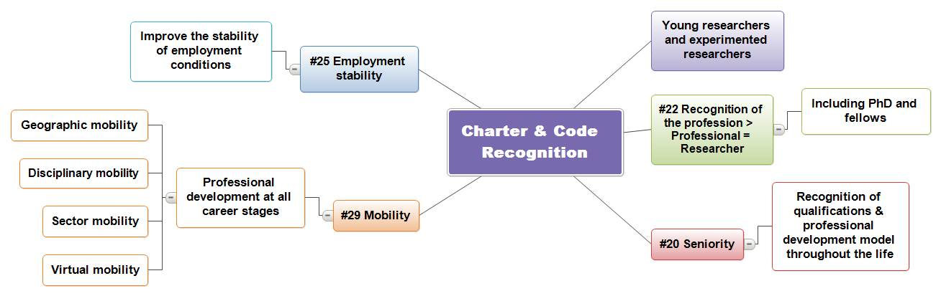

#20. Seniority (Code) The levels of qualifications required should be in line with the needs of the position and not be set as a barrier to entry. Recognition and evaluation of qualifications should focus on judging the achievements of the person rather than his/her circumstances or the reputation of the institution where the qualifications were gained. As professional qualifications may be gained at an early stage of a long career, the pattern of lifelong professional development should also be recognised.
Law & regulations | Institutional Regulation and Practise | Actions
- Partnership of Wallonia-Brussels for researchers, 26 May, 2011  - Decree of July 19, 1991 on the career of research scientists, (M.B. 26.09.1991)  - Executive Order of 18 November 1991 on the implementation of the Decree of 19 July 1991 relating to the career of scientific researchers, M.B. 21.02.1992 |  | In fact, researchers at the University of Namur have many opportunities to supplement existing or acquire new qualifications, through the organization of internal seminars and other training, and to take part in external seminars, congresses or training.  Mobility is also encouraged so that researchers can learn new skills.  However, this policy varies from one department to another.  Action :  Green light

#22. Recognition of the profession (Charter) All researchers engaged in a research career should be recognised as professionals and be treated accordingly. This should commence at the beginning of their careers, namely at postgraduate level, and should include all levels, regardless of their classification at national level (e.g. employee, postgraduate student, doctoral candidate, postdoctoral fellow, civil servants).
Law & regulations | Institutional Regulation and Practise | Actions
- Partnership of Wallonia-Brussels for researchers, 26.05.2011  Action 10: Examine the modalities for the creation of a proper status for the "new careers" in research | From the moment of their recruitment as a research assistant, researchers are treated as professionals.  . | Actions  - Introduce the dual concept of "young researchers" and "experienced researchers" as recommended in the Charter and the Code.  Consider how to introduce this dual notion within the University of Namur, the duties and obligations of each of these two categories and analyse the consequences that the use of these terms could imply in terms of organisation and interrelations respectively .  - In particular, this dual concept could be used in the compositions of advisory bodies and recruitment committees.  - This approach suggests a way out of the current dichotomy "academic staff" versus "scientific staff" as concerns all the aspects not related to their status.  - Harmonize the rules so as to define a regulation on the management policy of the career of scientific staff notpaid through operational budget, including payments for outside work, based on those applicable for statutory researchers.

#25. Stability and permanence of employment (Charter) Employers and/or funders should ensure that the performance of researchers is not undermined by instability of employment contracts, and should therefore commit themselves as far as possible to improving the stability of employment conditions for researchers, thus implementing and abiding by the principles and terms laid down in the EU Directive on Fixed-Term Work.
Law & regulations | Institutional Regulation and Practise | Actions
- Partnership of Wallonia-Brussels for researchers, 26.05.2011  Action 9 – Promote the quality and the continuity of researcher’s careers as well as the legibility of their status..  - Notification A 1011 of the Council of Scientific Policy  Collective Labour Agreement No. 25 of 15 October 1975 of the National Labour Council on equality of remuneration between men and women  Made mandatory by the R.D. of 9 December, 1975 (M.B. 25.12.1975).  Amended by the National Labour Council Collective Labour Agreement No. 25 bis of 19 December 2001, made mandatory by the R.D. 4 February, 2002 (M.B., 12.03.2002)  - Law of 12 April, 1965 on the protection of the remuneration of the workers, (M.B, 30 .04. 1965)  - Law on mandatory health care and co-ordinated compensation insurance of 14 July 1994 (M.B. 27.08.1994)  - Collective Labour Agreement No. 38e of 10 October, 2008 amending the Collective Labour Agreement No. 38 of 6 December 1983 on the recruitment and selection of workers | A policy has tended to develop privileging a permanent contract for those working for or long present at the University of Namur (Bureau of the Board of Directors n° 77, point B252 of 14/02/2011)  - Status of scientific staff paid through operational budgets  3.2.4. Contract renewal.  Article 53: The first appointment granted for a term of two years, can be renewed twice. In case of non-renewal, the applicant is notified of the duly justified decision at least three months before the expiry of his/her mandate. Part-time titular assistants are appointed for 2 year terms, renewable 5 times, as long as through this, he/she has not acquired six years of scientific seniority.  Article 56: Where exceptional circumstances warrant, the assistant can be appointed by the Board of Directors, following the renewal terms laid down in articles 54 and 55, for an additional term of one year, renewable a maximum of three times.  - Status of academic staff:  Art. 5. - Academic staff is appointed for life.  However, when there is a vacancy, the Board of Directors will, unless duly justified, give the appointment for a term of two years if the selected candidate joins the academic staff of the University of Namur for the first time.  The appointment is immediately definitive if the successful candidate is already a member of the permanent scientific staff of the University of Namur or holds a permanent mandate from the FNRS at the University of Namur.  The number of equivalent full-time positions so appointed for a term of two years may not exceed the proportions laid down in the legislation in force.  A the end of the two year term referred to above, any appointment is permanent if the position is at least half-time. If the position is less than half-time, the temporary appointment may be renewed. The evaluation criteria on which the Board of Directors bases its decision to confirm an appointment are set out in Annex I to the present Statutes.  Art.6. - Considerations concerning academic staff at the end of their career are given in Annex IIa.  After their admission to emeritus or honorary status, academic staff continues as members of the academic staff. Their duties shall end under the terms provided for in Art. 48. The Art. 1 to 4 also apply to them.  "Retired academic staff may be authorized by the Board of Directors to pursue certain activities of teaching, research and service to the community on an annual basis, but no later than the end of the academic year in which they reach the age of 70 years..." | The contract length is theoretically related to the financial resources made available by the sponsor. But in fact, the length of contracts is not always linked to that of funding.  Action :  - Create a list of cases of clear contract or work instability and consider possible solutions to resolve the situation:  - Inventory of the existing situation: list the various cases of contract or work instability that may arise.  - Solutions to propose: consider if solutions can be found for the cases listed.

  - Complaints and appeals process, and participation in university bodies
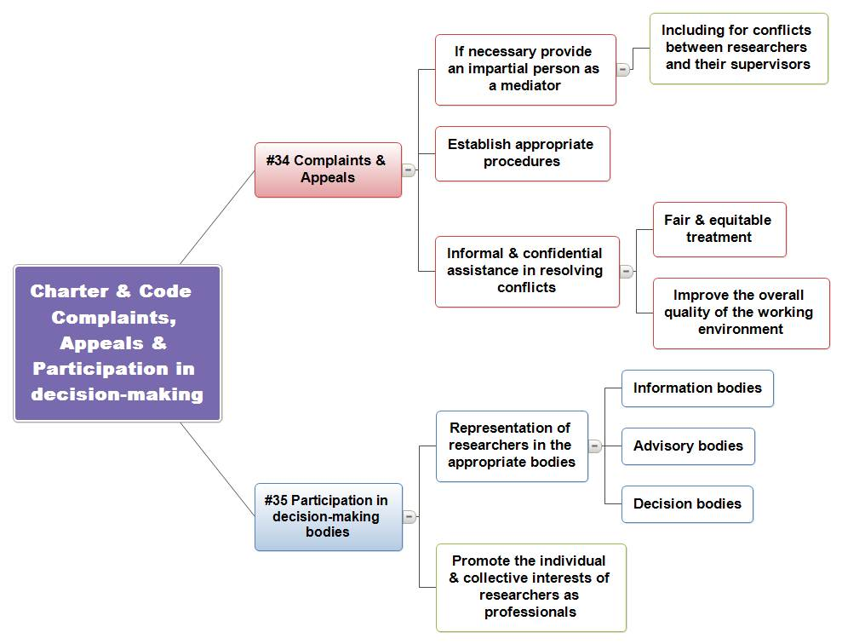

#34. Complaints/appeals (Charter) Employers and/or funders of researchers should establish, in compliance with national rules and regulations, appropriate procedures, possibly in the form of an impartial (ombudsman-type) person to deal with complaints/appeals of researchers, including those concerning conflicts between supervisor(s) and early-stage researchers. Such procedures should provide all research staff with confidential and informal assistance in resolving work-related conflicts, disputes and grievances, with the aim of promoting fair and equitable treatment within the institution and improving the overall quality of the working environment.
Law & regulations | Institutional Regulation and Practise | Actions
- R.D. 17 May, 2007 on the provision of psycho-social support of workers in the context of workplace violence, bullying or sexual harassment (M.B. 06.06.2007)  - Decree of the Government of the French Community of 26 July 2000 organizing the protection of their staff and that of certain public interest organizations against sexual harassment or bullying in the workplace  - R.D. of March 27, 1998 relating to the policy of worker welfare during the execution of their work (M.B. 31.3.1998) and all decrees of execution that modify it  Decree of 19 July 1991 relating to the career of scientific researchers, Art.8 & 9, in case of disagreement on recognition of qualifications (M.B. 26.09.1991)  - Doctoral regulations of the Académie universitaire ‘Louvain’  It provides that any conflict between the doctoral student and their sponsors or support committee is the responsibility of the doctoral committee of the concerned discipline. The doctoral commission of the concerned discipline decisions may be appealed to the Academy doctoral committee. | Different structures and appeal procedures exist and are part of the statutes of the scientific and academic staff of the University of Namur:  Rules  - Scientific staff paid through operational budgets  - Article 13: deals with a conflict between a member of the scientific staff and a member of the academic staff,  - Articles 91-103: these statutes have a disciplinary component , which provides for a board of appeal to which the staff member may apply in case of a dispute regarding a sanction;  - Annex IV of the Statute: appeal in the case of a verification of work incapacity.  - Academic staff - Board of appeal, disputes, sanctions and appeals  Articles 52 to 55 of the statutes deal with appeal procedures.  Complaints and appeals procedures  - Formalized procedure in the Work Rules: The complaint procedure is laid out in the Work Rules.  - Registering and management of a complaint  CPPT  The Committee for Occupational Health and Safety (CPPT) is empowered to receive all complaints relating to interpersonal conflicts at work.  To do this, a small subcommittee is designated; it is convened at the initiative of a member of the committee and meets in private.  Trusted individuals  Four people have been designated and trained as 'trusted individuals' to assist employees in the event of harassment.  In addition, they have responsibility to keep the complaint register up to date.  SEPPT  The University of Namur has retained the services of a consultant occupational psychologist from the, not for profit, CEsI.  Mediation unit  Within the University of Namur, the most innovative structure is the mediation unit to which a complaint may be made in the case of interpersonal conflict. This unit does not override the other statutory or legal avenues. It can redirect a request when it considers that the applicant has a right of appeal under statutory or legal provisions in force.  - A monitoring structure  SIPPT (Internal prevention service for Occupational Health and Safety): there is, within the University of Namur, a service whose mission is health and safety in the workplace. The SIPPT mission is to assist employers and employees in the application of the legal provisions and regulations concerning the welfare of workers during the performance of their work. Four people have been designated and trained as 'trusted individuals' to assist employees in the event of harassment.  Its mission, among others, is to detect and investigate all situations harmful to staff, and to report to the Committee for Occupational Health and Safety (CPPT) | Conciliation procedures laid down in the statutes are not always effective.  Action :  - Improve the effective use of the conciliation procedures

#35. Participation in decision-making bodies (Charter) Employers and/or funders of researchers should recognise it as wholly legitimate, and indeed desirable, that researchers be represented in the relevant information, consultation and decision-making bodies of the institutions for which they work, so as to protect and promote their individual and collective interests as professionals and to actively contribute to the workings of the institution.
Law & regulations | Institutional Regulation and Practise | Actions
 | - Scientific Corps Council  There is a “scientific council corps” whose mission is to ensure the representation and defence of the general interests of the members of the scientific staff.  It has a mission of information including the following: (i) research and education policy, (ii) the status of the various categories of scientific staff, (iii) decisions internal or external to the University of Namur concerning scientists, (iv) the work of their representatives in the various bodies and commissions where they are present, and (v) the positions that these representatives are defended, without prejudicing the confidentiality ethically required for some issues.  It has a mission to represent the interests of the scientific staff.  It is composed of representatives of the various faculties as well as of scientific members elected by the General Assembly of the University of Namur.  - The Academic Corps Council  Its missions are as follows:  - ensure the compliance and constructive implementation of the status of the academic staff, without prejudice to the powers of the statute commission;  - be attentive to the policy of the institution in the areas of education, research and service to the community.  - build relationships with similar organizations in Belgium and abroad;  - defend the general interests of the academic staff of the University of Namur | Actions :  - Involve researchers not covered by standard contracts in decision making bodies.  - Define a clear policy for the integration of scientists with permanent contracts (e.g. FNRS research associate) in the structures and decision-making bodies (e.g. participation in unit staff meetings...)

  - Gender & non-discrimination

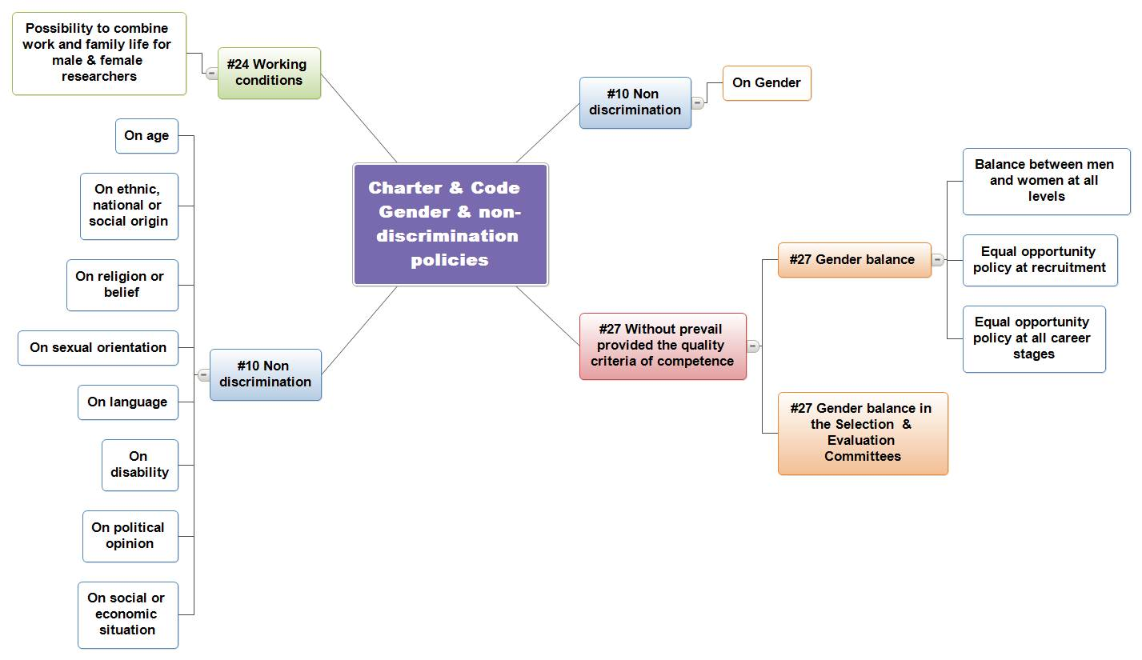

#10. Non-discrimination (Charter) Employers and/or funders of researchers will not discriminate against researchers in any way on the basis of gender, age, ethnic, national or social origin, religion or belief, sexual orientation, language, disability, political opinion, social or economic condition.
#27. Gender balance (Charter) Employers and/or funders should aim for a representative gender balance at all levels of staff, including at supervisory and managerial level. This should be achieved on the basis of an equal opportunity policy at recruitment and at the subsequent career stages without, however, taking precedence over quality and competence criteria. To ensure equal treatment, selection and evaluation committees should have an adequate gender balance.
Law & regulations | Institutional Regulation and Practise | Actions
- Collective labour agreement No. 38 of 6 December 1983 of the National Labour Council, concerning the recruitment and selection of workers (M.B. 28 July, 1984)  Inserted by Collective labour agreement No. 38ter of 17 July 1998, made mandatory by the R.D. of 8 October 1998 ( M.B. October 27, 1998), amended by the Collective labour agreement No. 38d of 14 July 1999, made mandatory by the R.D. of 31 August, 1999 (M.B. 21 September 1999)  - Decree of the Parliament of the French Community of 21 June 1993 relating to the feminization of the names of businesses, functions, ranks or titles, M.B. 19.08.1993  - Constitution coordinated by Belgium on 17 February 1994 (M.B. 17 February 1994) amended by the Law of 11 February, 2002 (M.B. 26 February, 2002), art. 10, 11 and 11 Bis  - Decree of the Walloon Government of 10 July 2003 on the establishment of a Walloon Council of equality between men and women (M.B. 18.08.2003), modified by R.D. GW 17 April, 2008 (M.B. 24 04.2008).  Anti-discrimination laws  - Law of 10 May 2007 to combat certain forms of discrimination  (BS 30 V07) (amended by the law of 30 December, 2009, with various provisions, Art. 107-119 MB. (31.12.2009)  This Law provides "a framework for combating discrimination based on age, sexual orientation, civil status, birth, wealth, religion or belief, political opinions, union affiliations, language, current or future health status, disability, physical or genetic characteristics, or social background"  - Law of 10 May 2007 to combat discrimination between women and men, (M.B. 30.05.2007)  This Law prohibits discrimination based on sex. This Law includes any distinctions based on pregnancy, childbirth, motherhood, or sex-change.  - Law of 10 May 2007 amending the Law of 30 July 1981 to suppress certain acts inspired by racism and xenophobia, (M.B. 30.05.2007)  transposing Directive 2000/43/EC of the Council of 29 June 2000 on the implementation of the principle of equal treatment between persons irrespective of racial or ethnic origin  - Decree of 12 July 2012 with various measures for the implementation of the protocol of understanding of April 7, 2011 in higher education (M.B. 1.08.2012 -)  Extension of contracts and mandates linked to research activities following pre-natal and post-natal leave .  - Diversity Charter of the Walloon Region  - Partnership of Wallonia-Brussels for researchers, May 26, 2011  - Research strategy 2011-2015 - towards an integrated research policy - Walloon Government and the Wallonia-Brussels Federation, December 2011 | - Charter of the University of Namur  "The Humanist and Jesuit heritage is reflected in the University of Namur by a confident openness to the world and a particular attention to humanity." In the spirit of justice, the university attaches a special concern to those that history has left poor, marginalized, or oppressed. Within the university community, this attention to the human being is shown in the respect, trust and recognition of the contribution of each to the common task."  - Recruitment Charter of the University of Namur, Board of Directors 607 June 17, 2011  Art. 8 - Diversity: the institution's recruitment policy is driven by a desire for diversity, such as varied ages, genders and experience.  Any selection using non-work based criteria (religion, age, sex, political opinion, ethnic origin, disability, union membership,...) is not acceptable and proscribed."  - Diversity Charter signed in 2010  - "Axel program - Together, let’s build excellence” General Assembly 137 of October 28, 2011  Axis 2 - Develop a management of human resources based on the skills and commitment of all  "The directions already taken as part of a "planned HR management" should lead to the development of effective and fair human resources management. It is based on matching people to the requirements of the work, developing their skills, allowing the freedom for their creativity, their implication in the success of their faculty's or service's objectives, as well as identifying conditions for increased mobility.  This program thus covers all the areas of human resource management - selection, career, mobility, training…”  Axis 8 - Integrating sustainable development into our activities and our campus  … "Our university maintains its efforts of structural cooperation with the South in a spirit of partnership and through the opening of its Masters programs... and its research, in the service of the global society.”  - Service note from the Human Resource department on the extension of the mandates and contracts linked to research activities following prenatal and postnatal leave (Decree 12/07/2012)  Extension of the contract or bursary for a period at least equal to the maternity leave (prenatal or postnatal), preventative prenatal and postnatal or paternity leave, however this extension cannot exceed one year. | Actions :  - Feminization of job titles  To establish appropriate feminine job titles, and grades commonly used at the University of Namur in order to institutionalize the feminization (including in the announcements of vacancies (and thus avoid m/f) ).  - Gender report: quantitative and qualitative analysis done every 2 years to measure the evolution of the situation and guide gender policy  The qualitative analysis will inventory the various measures implemented institutionally and from an HR perspective as part of the gender policy.  The statistical analysis should take into account the following elements:  - Analysis of staff with and without standard contracts;  - Analysis in absolute numbers and equivalent full-time;  - Analysis by orientation A/B.  - Refine the analysis on gender whenever possible by comparing the number of appointments with applications.  - Information and communication policy as concerns gender  Ensure transparency and communication of the gender report. (consideration of the most appropriate channels for this policy information).  - Adopt a gender equality charter  Study the overall direction the institution intends to take as concerns gender equality taking into account existing documents such as the diversity charter or the recruitment charter.

Fund for Scientific Research - National Fund for Scientific Research
Fund for Scientific Research - National Fund for Scientific Research
M.B. “Moniteur Belge” official publication of laws and statutes in Belgium. New laws or changes only take effect once it has been published here.
Fund for Scientific Research - National Fund for Scientific Research

